Wider Impacts of COVID-19 on Health (WICH) summary, 19 May 2022

Overview
This summary provides the main messages for some of the metrics updated in this release. It will cover Hepatitis C diagnoses, dementia and Alzheimer’s disease metrics including referrals to memory clinics and dementia diagnosis rate, and smoking quit attempts. Other updated themes not discussed include neurological care and alcohol.
Main messages
Hepatitis C
Figure 1 shows the laboratory confirmed new diagnoses of hepatitis reported to UKHSA from diagnostic laboratories via the Second Generation Surveillance System (SGSS). It illustrates that in March 2020 the number of hepatitis C virus (HCV) diagnoses dropped below 2019 levels and remained this way until November 2020. This decrease is mainly due to barriers in accessing testing because of the COVID-19 restrictions in place at the time. Between March and December 2021, the number of diagnoses are similar to the rates for 2019.
Figure 1: Number of new hepatitis C (HCV) diagnoses in England, January 2019 to December 2021

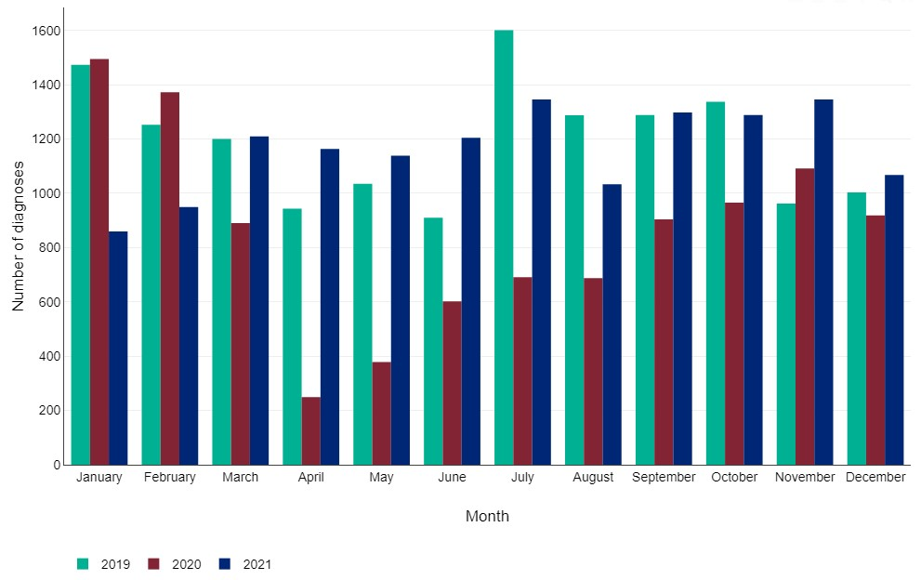
Dementia and Alzheimer’s disease
Prompt and early diagnosis of dementia enables people living with dementia, their carers and healthcare staff to plan accordingly and work together to improve health and care outcomes. The majority of diagnoses for dementia are established following a referral to a memory clinic. Primary care practitioners can refer individuals to a memory clinic if they suspect the potential for dementia.
As a consequence of the COVID-19 pandemic, referrals to memory clinics from primary care practitioners reduced in April 2020. Referral numbers remained flat until June 2021 and by October 2021 there was evidence that referrals were returning to pre-pandemic levels (Figure 2).
Figure 2: Cumulative count of referrals to memory clinics (all ages), 2017/18 to March 2021/22, England
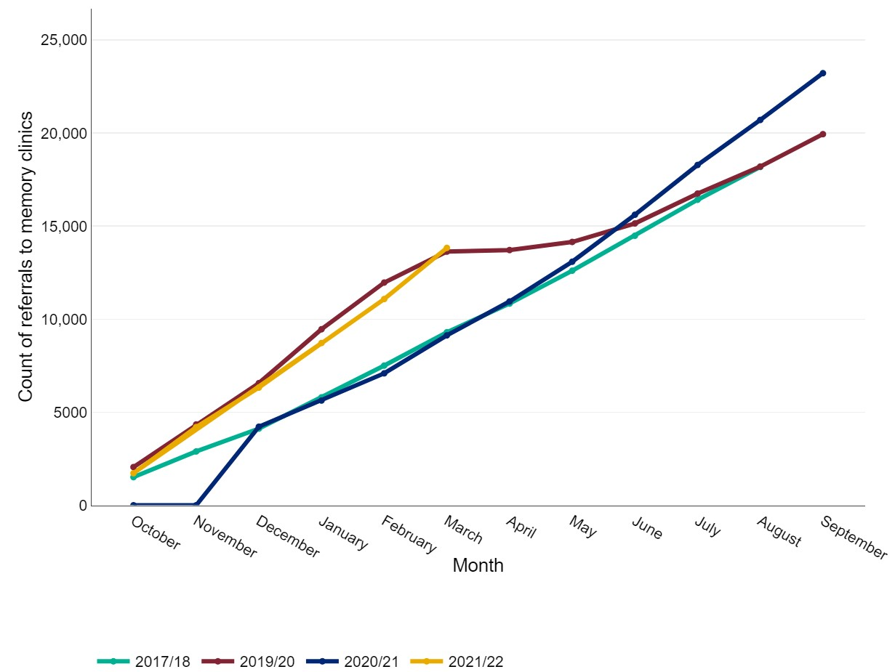

The Estimated Dementia Diagnosis Rate (EDDR) measures the number of people with a formal diagnosis of dementia as a percentage of those estimated to be living with dementia. The current aspiration is that 66.7% of people with dementia have a formal diagnosis. During wave 1 of the pandemic, the EDDR decreased to below the aspired level and has remained below since then (Figure 3).

Figure 3: Estimated dementia diagnosis rate (aged 65 and over), 2019 to March 2022, England
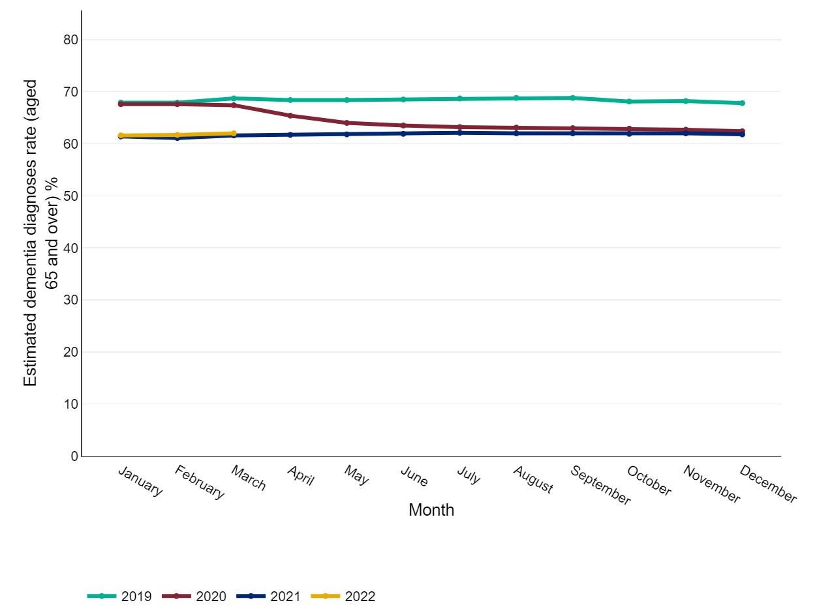

Following a formal diagnosis of dementia, an individual should receive a dementia care plan that addresses their current needs. Primary care practitioners have the responsibility for managing care of people with dementia post diagnosis and this includes a Quality Outcome Framework requirement to review dementia care plans to ensure they remain contemporary to the needs of the individual. The aspiration is that 75% of dementia care plans are reviewed annually. Between March 2020 and January 2021, the percentage of care plan reviews had decreased from the aspired level to under 40% and remained at this level until September 2021 (Figure 4). By March 2022, there is evidence to suggest that dementia care plan reviews were once again being undertaken but the level remained significantly under the baseline average.
Figure 4: Percentage of those with a dementia diagnosis with care plan or care plan review in the preceding 12 months (all ages), 2018-19 to March 2022
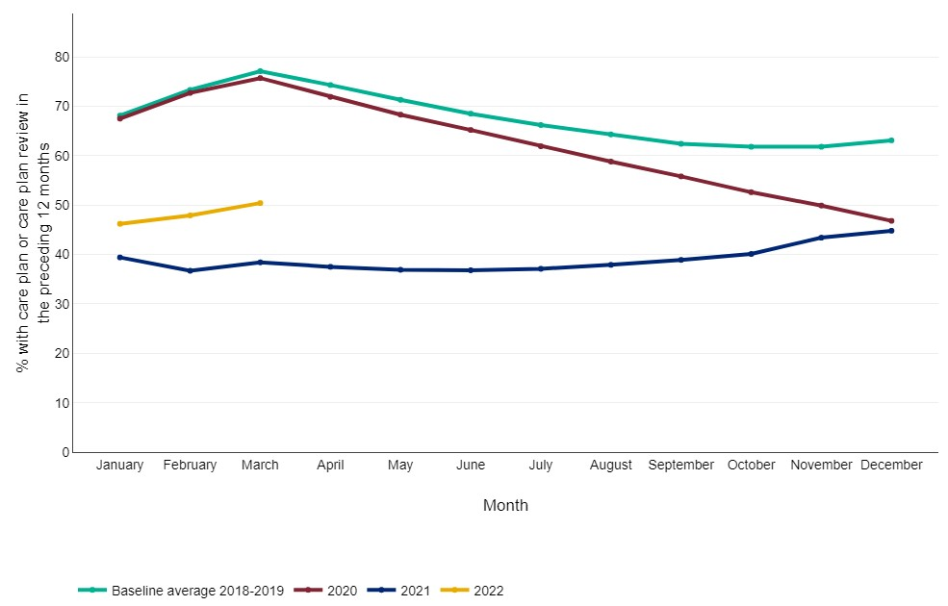

Smoking quit attempts
The Smoking Toolkit Study is a monthly household survey, which each month involves a new representative sample of between 1,700 and 1,800 adults. There was an increase in the percentage of people attempting to quit smoking from March to June 2020 (Figure 5). After that the percentage fluctuated but remained consistently higher than 2019. From May 2021 to October 2021, the number of people attempting to quit smoking increased from 34% to over 41% of smokers. Since December 2021, the percentage has gradually declined.
Figure 5: Percentage of smokers in the Smoking Toolkit Study making quit attempts, January 2018 to March 2022, in England
