Wider Impacts of COVID-19 on Health (WICH) summary, 16 March 2023

Overview

This summary provides the main messages for some of the metrics updated in this release. It will cover employment indicators, such as number of job vacancies and redundancy rates, child physical activity, wellbeing and breast screening.

Main messages

Social determinants of health

Number of job vacancies in the UK

There is a strong evidence base showing that work is generally good for physical and mental health and wellbeing. Figure 1 shows the number of job vacancies has continued to decrease to 1,134,000 for the quarter November 2022 to January 2023, from a recent peak of 1,294,000 in the quarter February to April 2022.

Figure 1: Quarterly average of number of job vacancies in the UK (thousands) (seasonally adjusted), United Kingdom, November 2018 to January 2023
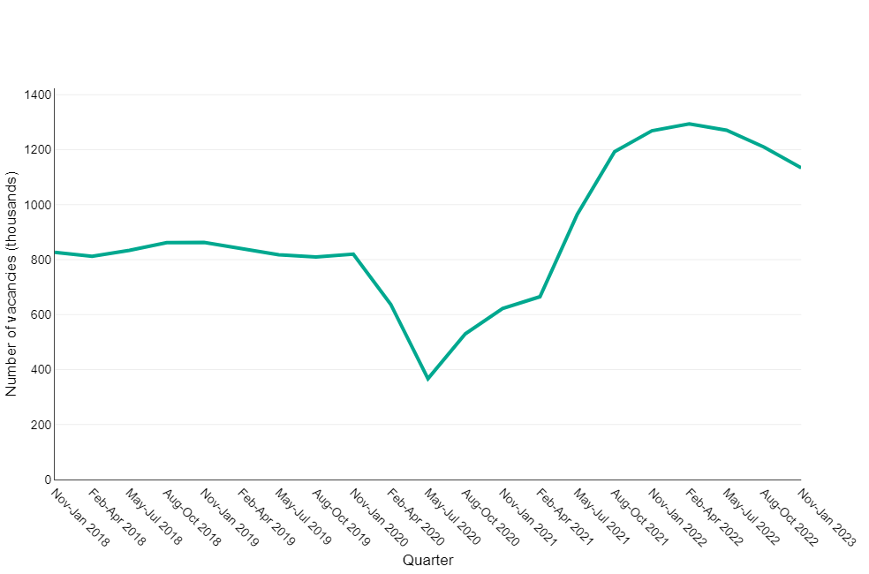

Source: Vacancy Survey, Office for National Statistics

Redundancy rate

Figure 2 shows the redundancy rate for all persons has continued to increase to 3.5 per 1,000 employees for the quarter October to December 2022, from 1.9 for the quarter April to June 2022. This remains below levels from a peak during the pandemic where the redundancy rate reached 12.8 per 1,000 employees for the quarter October to December 2020.

For the same period a larger increase in redundancy rate is observed for males. For the quarter October to December 2022 redundancy rate reached 4.5 per 1,000 employees, an increase from 2.1 for the quarter April to June 2022. This figure is below the redundancy rate at the peak of the pandemic (14.7 per 1,000 employees for the quarter October to December 2020).

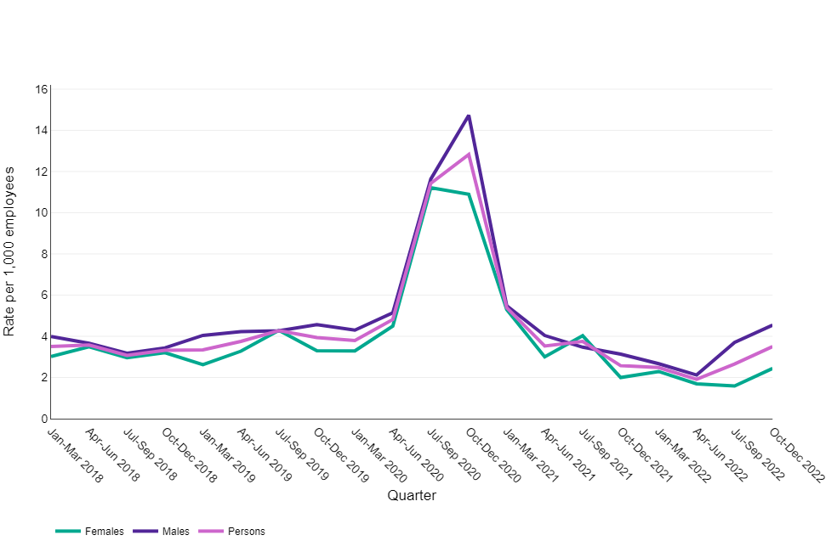
Figure 2: The ratio of redundancy level to the number of employees by sex, January 2018 to December 2022, England

Source: Labour Force Survey, Office for National Statistics

Wellbeing

Low life satisfaction

This data enables us to explore whether the pandemic has had an impact on the percentage of people experiencing low levels of life satisfaction.

Figure 3 shows the percentage of respondents with a low life satisfaction score. This percentage has been increasing since December 2021. The November 2022 figure (10.3%) was higher than both the 2019 baseline (5.7%) and October 2021 (8.4%). However, it was 0.1 percentage points lower than the November 2020 (10.4%) when the second lockdown came into force in England.

Figure 3: The percentage of survey respondents with low life satisfaction (score 0-4) in England, June 2020 to November 2022
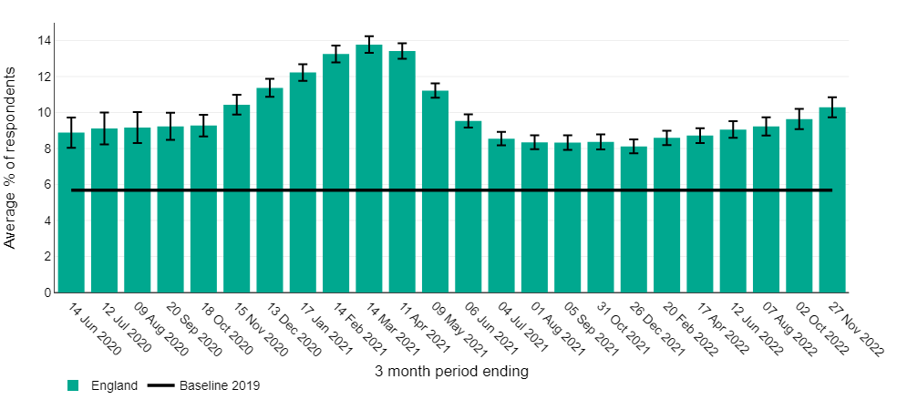

Source: PHE/OHID analysis of Opinions and Lifestyle Survey data from Office for National Statistics

Behavioural risk factors

Child physical activity – Active lives survey

Figure 4 shows that for all three school terms of the 2021 to 2022 academic year the percentage of physically active children (aged 5 to 16 years) was higher than the respective terms of the 2020 to 2021 academic year and have returned to pre-pandemic levels. The UK Chief Medical Officers (CMO) currently recommend that children and young people (5 to 18 years) are physically active for an average of at least 60 minutes per day across the week.

Figure 4: Percentage of children and young people aged 5-16 years that met the UK Chief Medical Officers' recommendations for physical activity, England, Autumn 2018 to Summer 2022
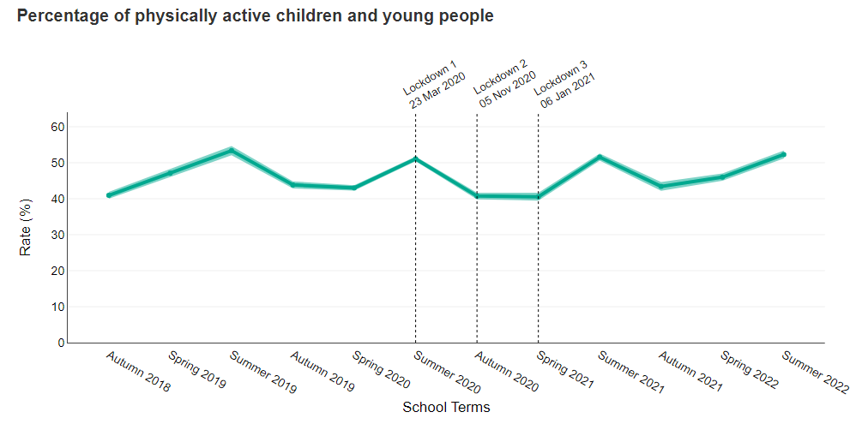

Source: Active Lives Children and Young People Survey, Sport England

Impact on healthcare

Breast screening round length

Breast screening is offered to women aged 50 to 71 years of age every 3 years to maximise the chances of finding breast cancers at an early stage when they are too small to see or feel. This indicator aims to show the restoration of breast screening services following a pause in invitations between April and June 2020.

Figure 5 shows the proportion of women aged 50 to 73 years who were offered a subsequent appointment for breast screening within 36 months of their last attended appointment or date of first offered appointment for women who did not attend. The proportion has continued to increase to 54.3% in Quarter 1 2022/23, from 45.7% in Quarter 4 of 2021/22. Breast cancer screening services have been negatively affected by the COVID-19 pandemic and this proportion remains below pre-pandemic levels of 81.8% (Quarter 4 2019/20) and below the ‘acceptable level’ for this standard 90% and over.

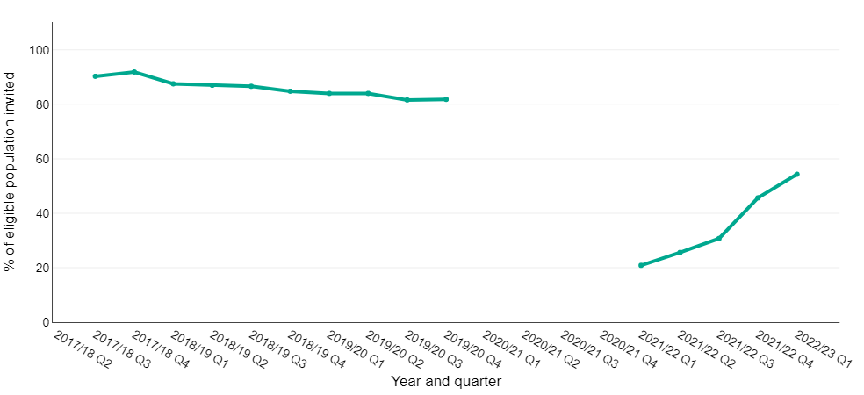
Figure 5: Proportion of women eligible for breast screening whose date of first offered appointment is less than or equal to 36 months of their previous episode, England, Q2 2017/18 to Q1 2022/23

Chart note:
Gap in line indicates where data have been withdrawn due to poor data quality during the pandemic and the change in the IT reporting system.

Source: Screening key performance indicators, NHS England and NHS Improvement

Breast screening uptake

This indicator shows the proportion of women offered screening who have a technically adequate screen within 6 months of the date of first offered appointment. As shown in figure 6 the proportion has remained stable at 55.5% for Quarter 1 2022/23, compared to 53.3% in Quarter 4 2021/22. This proportion remains below the ‘acceptable level’ of 70%.

Figure 6: Proportion of women eligible for breast screening who have a technically adequate screen less than or equal to 6 months of date of first offered appointment, England, Q2 2017/18 to Q1 2022/23
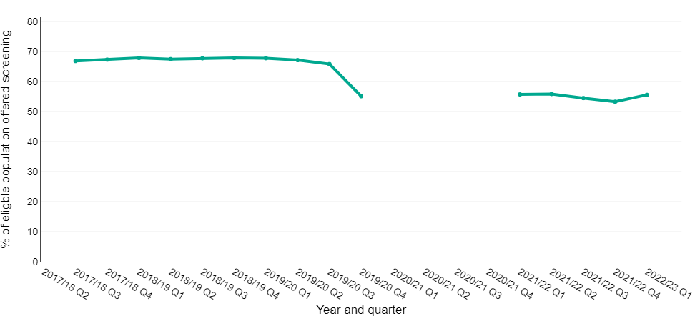
Chart note:
Gap in line indicates where data have been withdrawn due to poor data quality during the pandemic and the change in the IT reporting system.

Source: Screening key performance indicators, NHS England and NHS Improvement

