Wider Impacts of COVID-19 on Health (WICH) summary, 17 March 2022

Overview
This summary provides the main messages for some of the metrics updated in this release. This release will cover the life satisfaction and anxiety metrics in the wellbeing theme, which have been revised and updated, and job vacancies and redundancy rate in the employment and income theme. Other updated themes not discussed include life expectancy, neurological care, alcohol and smoking.
Main messages
Wellbeing
In this release, metrics on wellbeing and loneliness have been revised to enable better interpretation of the impact of the pandemic. Data from the Opinions and Lifestyle Survey (Office for National Statistics) has been grouped into broader three-month time periods to assess trends.
Figure 1 shows that from the three-month period to 14 June 2020, through to the latest three-month period ending 26 December 2021, respondents in England reported lower life satisfaction than in 2019 (baseline of 5.7%). In the three months to 14 March 2021 (lockdown 3 period), low life satisfaction peaked at 14%, significantly higher than in the most recent three months to 26 December 2021 when 8.1% of respondents reported low life satisfaction.
Figure 1: Trend in the percentage of respondents reporting low life satisfaction (score 0-4), three-month rolling average, England, June 2020 to December 2021
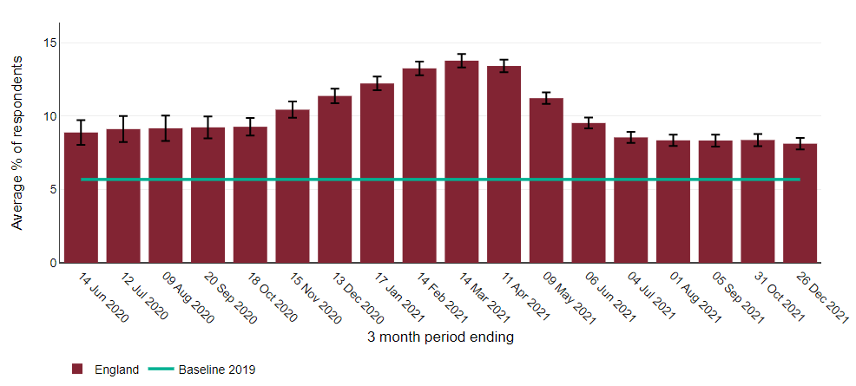
Source: OHID analysis of Opinions and Lifestyle Survey data from Office for National Statistics, 2021
Between the three-month periods ending 18 October 2020 and 13 December 2020, the lowest earners (up to £10,000) had a significantly higher percentage of respondents with low life satisfaction compared to all other respondents (Figure 2). However, recent data shows this gap has narrowed with lowest earners having similar low life satisfaction levels to respondents with annual incomes of £10,000 up to £15,000 and £15,000 up to £20,000.
Figure 2: Trend in the percentage of respondents reporting low life satisfaction (score 0-4), three-month rolling average, by annual income (£), England
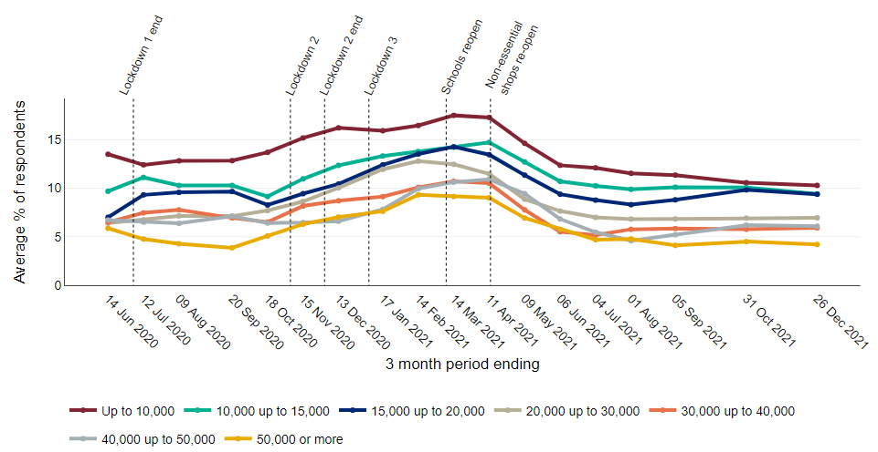
Source: OHID analysis of Opinions and Lifestyle Survey data from Office for National Statistics, 2021

During 2020 and 2021, respondents reported significantly higher percentages of anxiety than in 2019 (Figure 3). Figure 4 shows that in the three-month period to 14 February 2021, 46% of unemployed respondents had high anxiety, significantly higher than those who were economically inactive (37%) and employed/self-employed (35%). The latest data to 26 December 2021 show that those who are unemployed have statistically similar percentages of respondents with high anxiety (39%) compared with those who are economically inactive (34%) and employed/self-employed (32%).

Figure 3: Trend in the percentage of respondents reporting high anxiety (score 6-10), three-month rolling average, England, June 2020 to December 2021
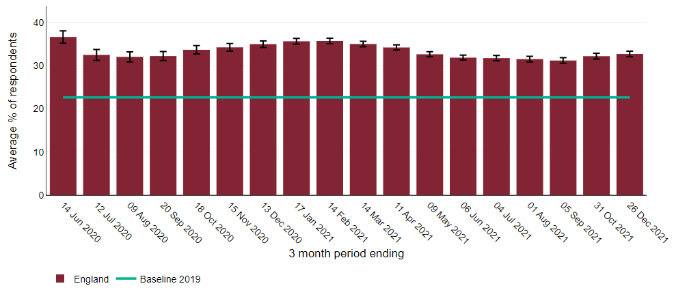
Source: OHID analysis of Opinions and Lifestyle Survey data from Office for National Statistics, 2021
Figure 4: Trend in the three-month rolling average percentage of respondents to the Opinions and Lifestyle Survey with high anxiety (score 6-10), in England by economic activity
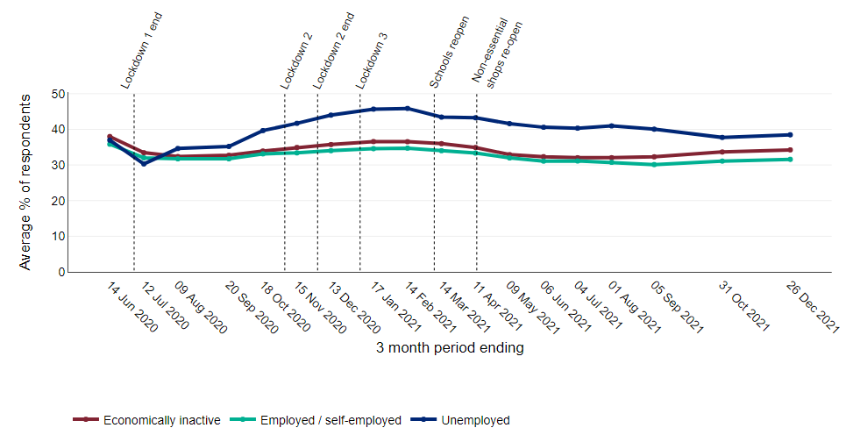
Source: OHID analysis of Opinions and Lifestyle Survey data from Office for National Statistics, 2021

Employment and Income
After remaining at a fairly constant level throughout 2018 and 2019, the number of job vacancies in the UK more than halved from 803,000 vacancies in the November 2019 to January 2020 quarter, to 375,000 in May to July 2020 when the first lockdown was in place. The number of job vacancies has risen in each quarter since this low point, surpassing the pre-pandemic level and reaching 1,298,000 vacancies in the November 2021 to January 2022 quarter (Figure 5).
Figure 5: Number of job vacancies in the UK (thousands), seasonally adjusted, from November 2017 to January 2022
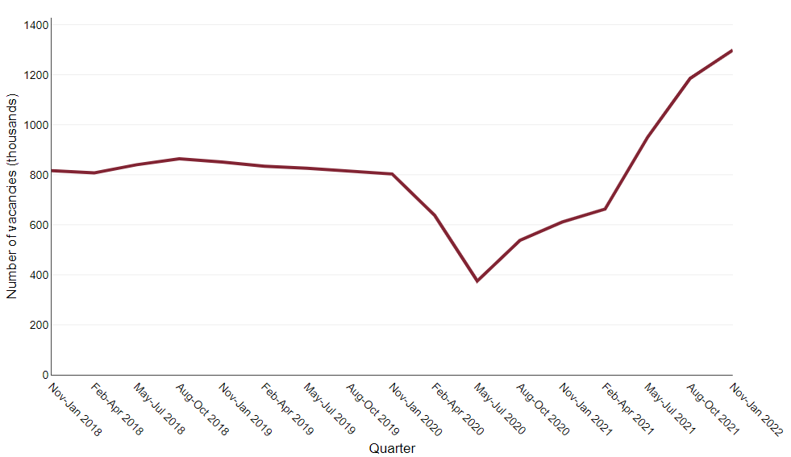
Source: Vacancy Survey, Office for National Statistics
The redundancy rate in the UK increased from 4.8 per 1,000 employees in the quarter April to June 2020 to 12.9 per 1,000 employees in the quarter October to December 2020 (Figure 6). In the following quarters the rate decreased sharply, returning to pre-pandemic levels in April to June 2021. In the most recent quarter, October to December 2021, the rate decreased to 2.6 per 1,000 employees which is below pre-pandemic levels. The redundancy rates for males and females follow similar patterns, the rate for females remaining slightly below males in all quarters between 2018 and 2021 except July to September 2021.

Figure 6: Redundancy rate (ratio of the number of redundancies in the three months prior to interview to the number of employees) in the UK, by sex, from January 2018 to December 2021
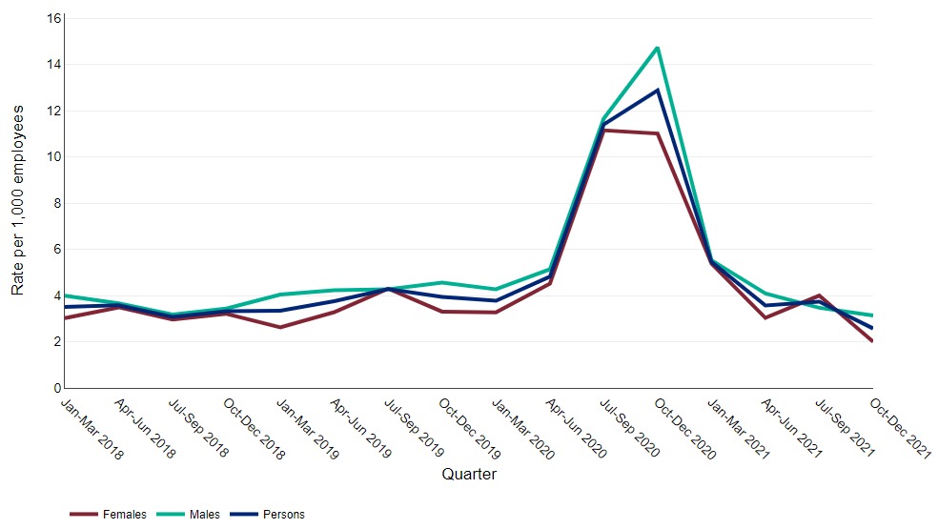
Source: Labour Force Survey, Office for National Statistics

