Wider Impacts of COVID-19 on Health (WICH) summary, 16 June 2022

Overview
This summary provides the main messages for some of the metrics updated in this release. It will cover the new indicators for Abdominal Aortic Aneurysm (AAA) screening, breast cancer screening and NHS Health Checks, as well updated themes such as wellbeing, employment and income.
Main messages
New Indicators: Screening
Screening is the process of identifying healthy people who may have an increased chance of a disease or condition and early detection. The screening provider then offers information, further tests and treatment. This is to reduce associated problems or complications.

Between April and June 2020 providers paused screening due to the COVID-19 pandemic. Screening providers restarted at varying times from June 2020 following approval of local plans to make sure that screening was carried out as safely as possible for attendees and staff. Invitations in the breast and Abdominal Aortic Aneurysm (AAA) screening programmes were prioritised according to risk (see metadata).

Abdominal aortic aneurysm (AAA)

Men who turned 65 in the screening year (April to the March of the following year) and haven’t had previous AAA surgery are offered a one-off ultrasound scan. Figure 1 shows the proportion of eligible cohort men who are screened for an AAA. The data is cumulative across the screening year. By the end of quarter 4 in 2017 to 2018, 2018 to 2019 and 2019 to 2020, approximately 77% of eligible men were screened.

The 4.4% shown in quarter 1 2020 to 2021 were eligible men who were screened early, prior to April 2020. Ongoing issues with access to venues, availability of staff and longer appointment times had an impact on the coverage of AAA screening. By the end of quarter 4 2020 to 2021 only 42.4% of eligible cohort men had been screened. By the end of quarter 2 2021 to 2022 coverage was below 43%, the national average for the same period in previous years but higher than the 8.8% reported by the end of quarter 2 2020 to 2021.

Figure 1: Proportion of eligible cohort men who have had a screen for an abdominal aortic aneurysm, April 2017 to September 2021, England

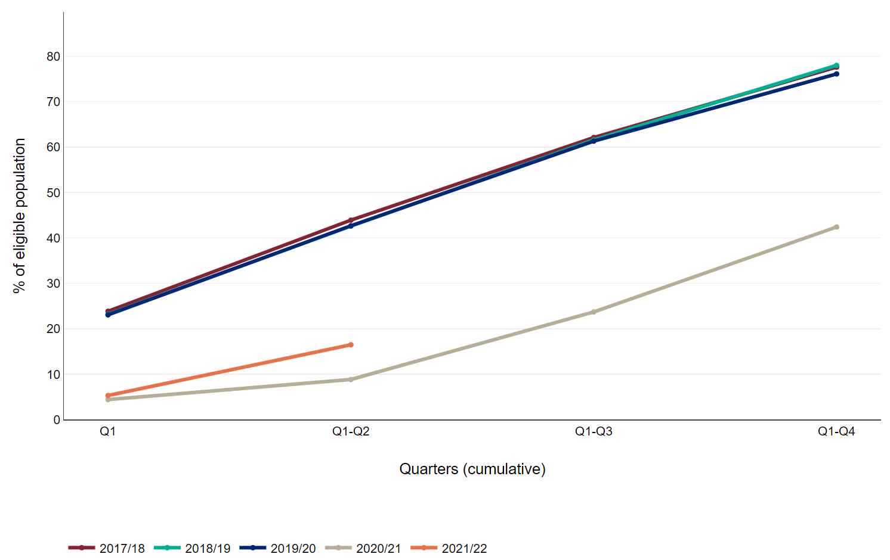

Source: Screening key performance indicators, NHS England and NHS Improvement

Figure 2 shows the proportion of annual surveillance appointments for AAA where there is a conclusive scan within 6 weeks of when the appointment is due each quarter (coverage). The annual surveillance scan is for men who are found to have a small aneurysm (aorta measures 3.0 to 4.4cm on ultrasound scan) at their initial screen (includes cohort men aged 65 and men aged over 65 who have self-referred). An annual surveillance scan is offered until the aneurysm reaches 5.5cm, when they are referred for treatment. Prior to the pandemic about 93% of appointments had a conclusive screen in the timeframe.

The proportion of appointments with a conclusive screen within 6 weeks fell to 74.5% in quarter 2 2020 to 2021. This reflects the varying start dates of providers after the pause and men’s reluctance to attend screening appointments early in the pandemic. The coverage of the annual surveillance scan improved to 86.2% in quarter 3 2020 to 2021. Anecdotal reports from providers suggested the decline in coverage to 81.7% in quarter 4 2020 to 2021 was due to men deferring their appointment until their second vaccine. Coverage fell to a low of 57.4% in quarter 1 2021 to 2022. This is mainly a reflection of the fact that very few men were due an appointment in this quarter, as screening was paused for the same quarter in the previous year.

Figure 2: Proportion of annual abdominal aortic aneurysm surveillance appointments due where there is a conclusive scan within 6 weeks either side of the due date, April 2017 to September 2022, England
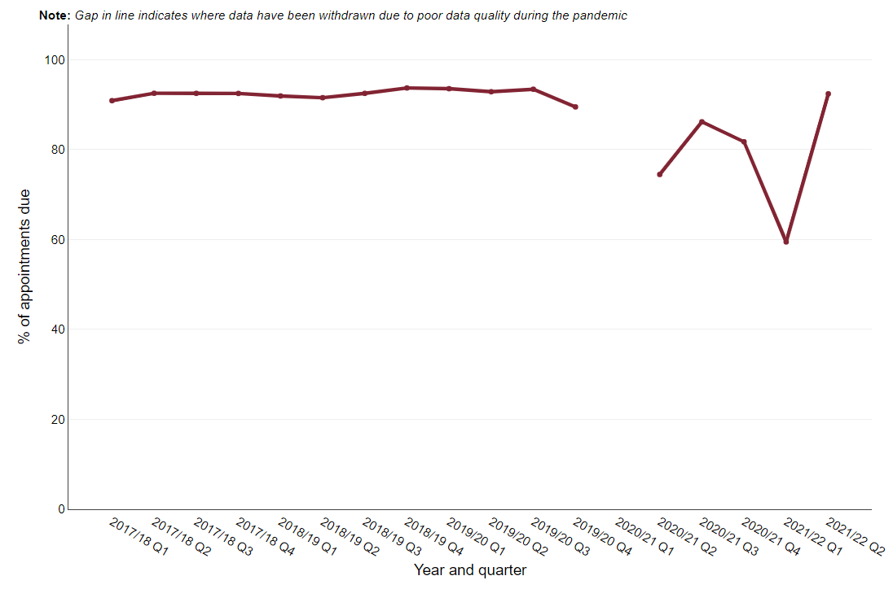
Source: Screening key performance indicators, NHS England and NHS Improvement

Figure 3 shows the proportion of quarterly surveillance appointments for AAA where there is a conclusive scan within 4 weeks of when the appointment is due each quarter (coverage). The quarterly surveillance scan is for men who are found to have a medium aneurysm (aorta measures 4.5 to 5.4cm on ultrasound scan) at their initial screen (includes cohort men aged 65 and men aged over 65 who have self-referred) or at their annual surveillance scan. Prior to the pandemic about 93% of appointments had a conclusive screen in the timeframe.

The proportion of appointments with a conclusive screen within 4 weeks fell to 76.6% in quarter 2 2020 to 2021. This reflects the varying start dates of providers following the pause and men’s reluctance to attend screening appointments early in the pandemic. The coverage of the quarterly surveillance scan has recovered to pre-pandemic levels of approximately 93%. There was a slight dip in quarter 3 2020 to 2021 to 88.8%. As noted above, this may reflect a desire to have their second vaccine before attending an appointment.

Figure 3: Proportion of quarterly abdominal aortic aneurysm surveillance appointments due where there is a conclusive scan within 4 weeks either side of the due date, April 2017 to September 2022, England

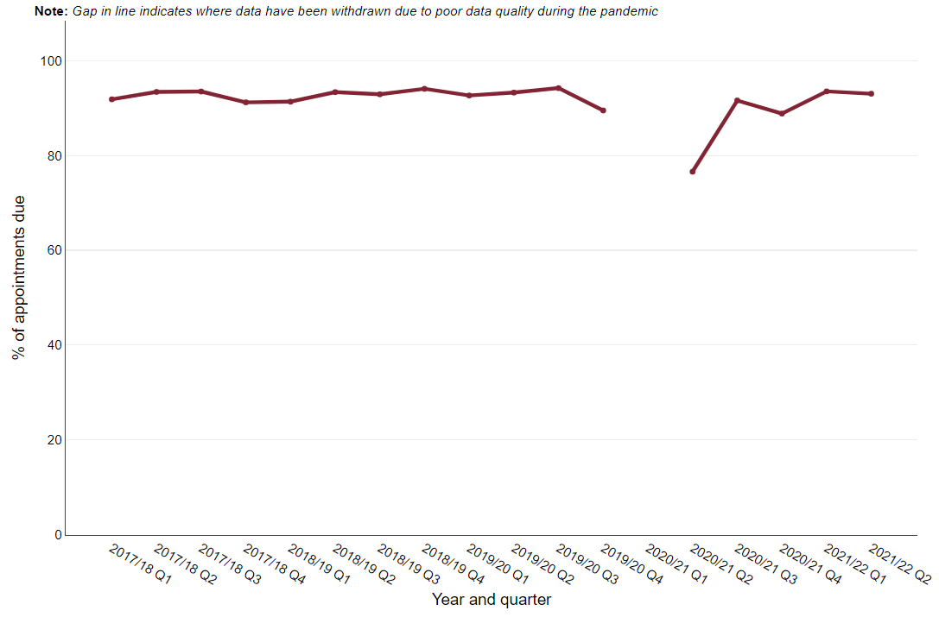
Source: Screening key performance indicators, NHS England and NHS Improvement

Breast cancer screening

Figure 4 shows the proportion of eligible women aged 50 to <71 who had a technically adequate breast screen within 6 months of their date of first offered appointment (uptake). Between April 2017 and December 2019 uptake was approximately 67% and it had declined from 77% in 2011.

In a bid to maximise the use of available appointments many providers changed to offering open appointments, where a woman receives a letter asking her to call to book an appointment. This required a change to the IT system used for breast screening and it affected how the system counted when an invitation had been made and could increase the time period between when the letter is sent to a woman and when she attends for a screen. This prevented the uptake being accurately measured during 2020 to 2021. For quarters 1 and 2 2021 to 2022 uptake was approximately 56%.

Figure 4 Proportion of eligible women who have a technically adequate screen less than or equal to 6 months of date of first offered appointment, April 2017 to September 2022, England

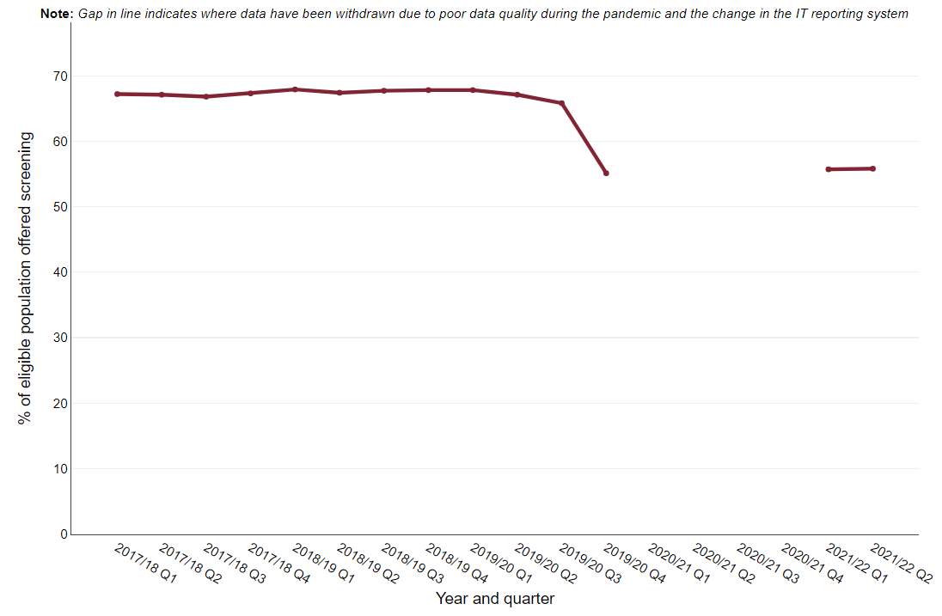
Source: Screening key performance indicators, NHS England and NHS Improvement

Figure 4 shows the proportion of eligible women who have had a previous invitation for breast screening, that have a subsequent invitation within 36 months (this proportion is known as the screening round length). It is important for women to receive a timely invitation in order to increase the chances of finding cancers early but reduce the harms of over diagnosis and radiation exposure. Breast screening round length has declined from 90.6% in quarter 1 2017 to 2018 to 81.8% in quarter 4 2019 to 2020.

Due to the number of women requiring screening that built up during the pause in screening many invitations were delayed. The screening round length of 21% in quarter 1 2021 to 2022 reflects the difficulties providers had with recovering from the effects of the pandemic on service provision. Screening round length is expected to improve as screening providers reduce the number delayed invitations.

Figure 5: Proportion of eligible women whose date of first offered appointment is less than or equal to 36 months of their previous episode*, April 2017 to September 2022, England
* The previous episode refers to date of screening for women who attended or date of first offered appointment for women who did not attend

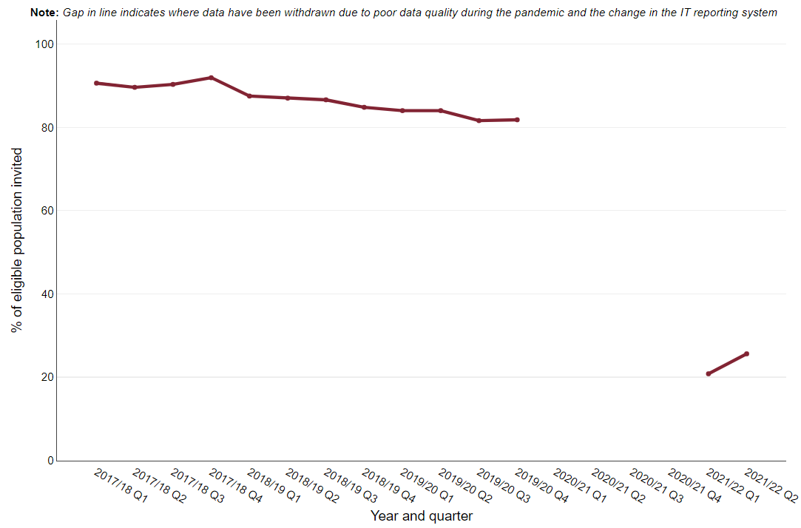
New Indicator: NHS Health Checks received
The NHS Health Check programme aims to prevent heart disease, stroke, diabetes and kidney disease, and some cases of dementia among adults aged 40 to 74 years who do not have an existing diagnosis of cardiovascular disease. Local areas are required to offer a check to all eligible people over a 5 year period. To meet this requirement, it is expected that about 5% of eligible people are invited for a check each quarter.
Figure 6 shows the proportion of eligible people who had an NHS Health Check each quarter since 2018 to 2019. It illustrates that the number of people having a check dropped in 2020 to 2021 and had not recovered by September 2021. Delivery of the programme – which is commissioned by local government and provided mainly in NHS primary care settings, was deprioritised because of the pandemic and in line with national guidance from NHS England. This resulted in phases of stop-start and restart of the programme, between April 2020 and February 2022. Local areas started to recover the service after this. However nearly three-times less checks were delivered in the first half of 2021to 2022 compared to similar time periods prior to the pandemic.
Figure 6: Percentage of NHS Health Checks received by the total eligible population in the quarter

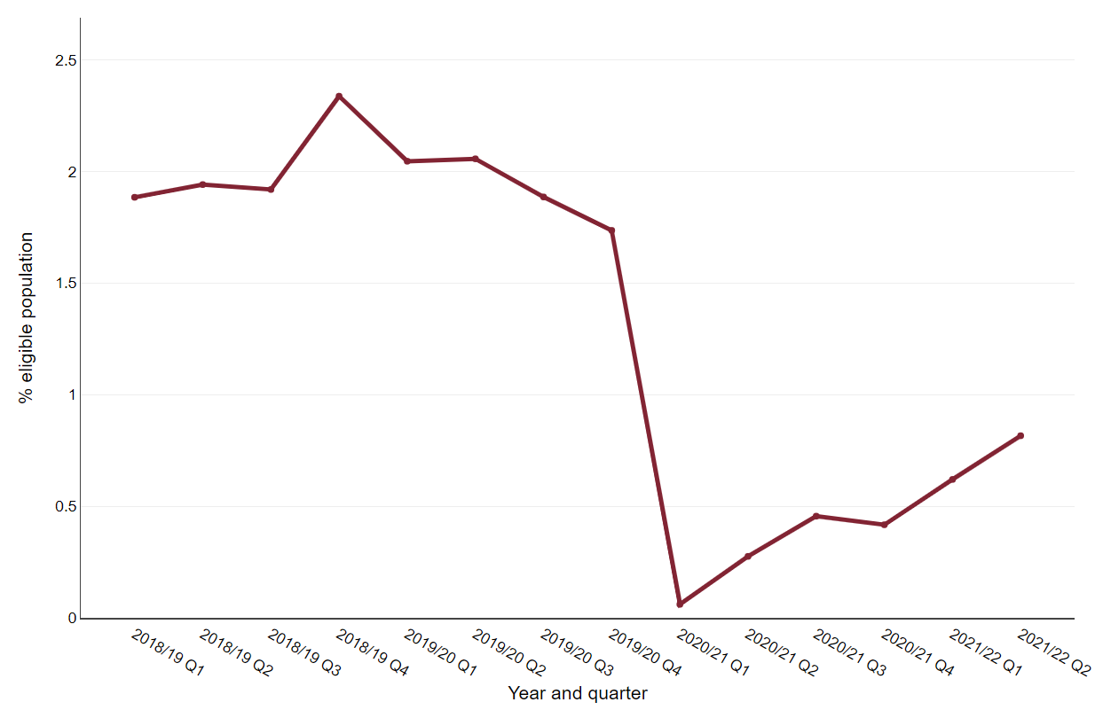
Source: OHID analysis of NHS Health Checks data
Wellbeing
In this release, metrics on wellbeing and loneliness have been updated.
Figure 7 shows that from the three-month period to 14 June 2020, through to the latest three-month period ending 17 April 2022, a greater percentage of respondents in the Opinions and Lifestyle Survey reported low life satisfaction than in 2019 (5.7%). In the three months to 14 March 2021 (third national lockdown), low life satisfaction peaked at 13.8%, significantly higher than in the most recent three months to 17 April 2022 when 8.7% of respondents reported low life satisfaction.
Figure 7: Trend in the percentage of respondents reporting low life satisfaction (score 0-4), three-month rolling average, England, June 2020 to April 2022
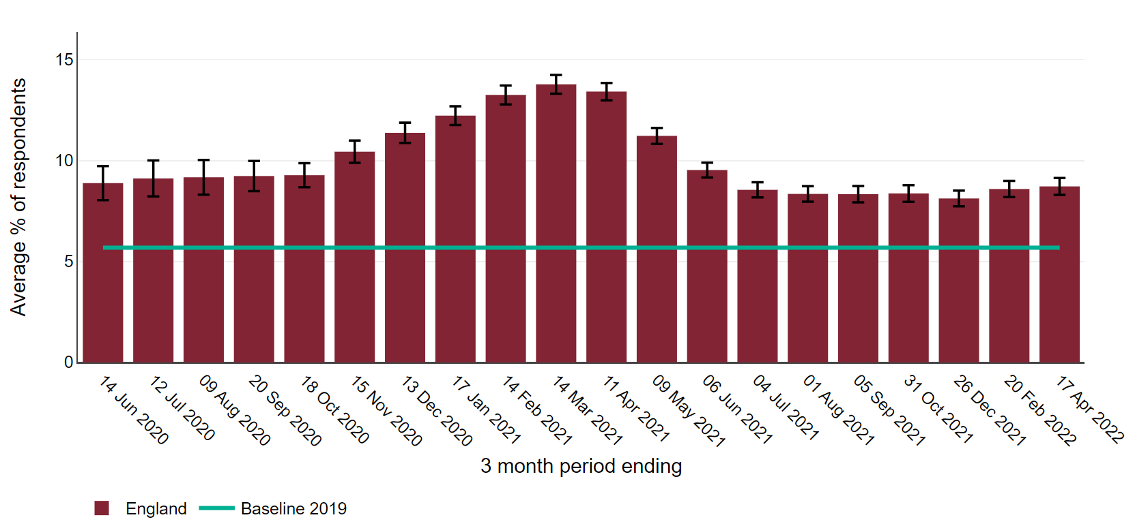
Source: OHID analysis of Opinions and Lifestyle Survey data from Office for National Statistics, 2022
Between the three-month periods ending 18 October 2020 and 13 December 2020, the lowest earners (up to £10,000) had a significantly higher percentage of respondents with low life satisfaction compared with all other respondents (Figure 8). However, recent data shows this gap has narrowed with lowest earners having more similar low life satisfaction levels to respondents with annual incomes of £10,000 up to £15,000 and £15,000 up to £20,000.
Figure 8: Trend in the percentage of respondents reporting low life satisfaction (score 0-4), three-month rolling average, by annual income (£), England
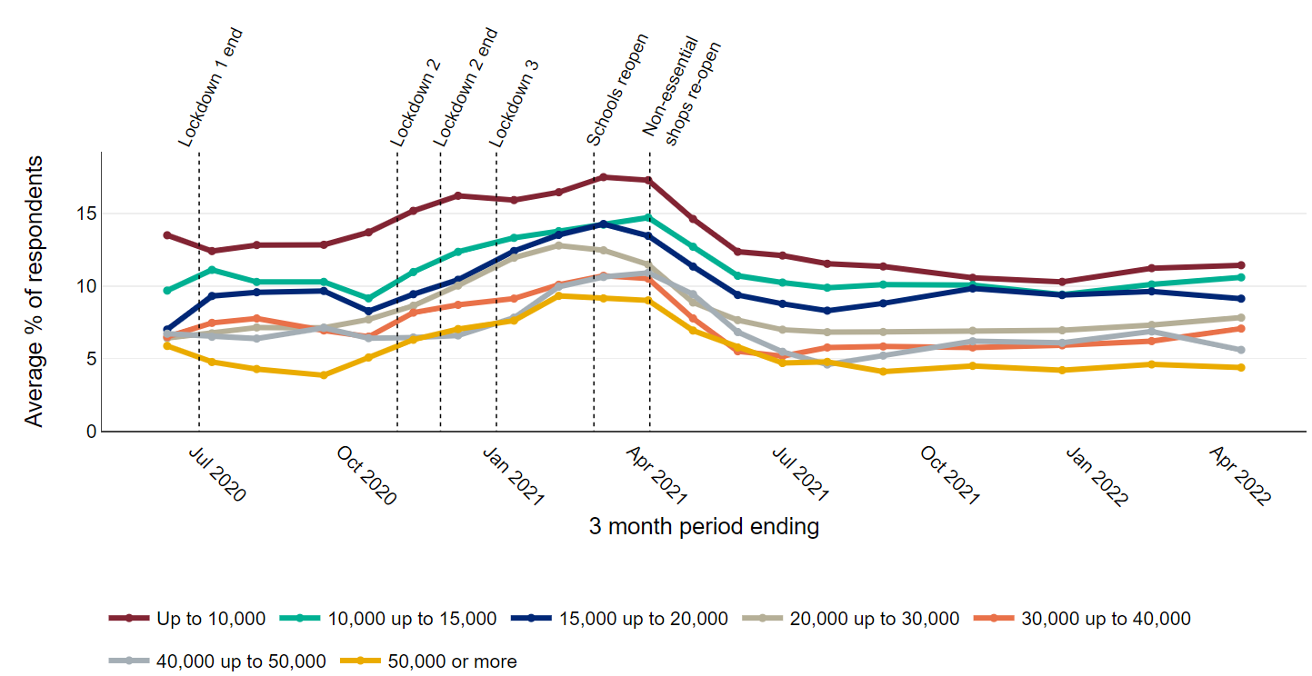
Source: OHID analysis of Opinions and Lifestyle Survey data from Office for National Statistics, 2022

Between June 2020 and April 2022, the percentage of respondents reporting high anxiety was significantly higher than in 2019 (Figure 9). Figure 10 shows that in the three-month period to 14 February 2021, 45.9% of unemployed respondents had high anxiety, significantly higher than those who were economically inactive (36.5%) and employed or self-employed (34.7%). The latest data to 17 April 2022 show that the percentage of unemployed people reporting high anxiety (39.4%) remained significantly higher than those who are employed or self-employed (32.4%).
Figure 9: Trend in the percentage of respondents reporting high anxiety (score 6-10), three-month rolling average, England, June 2020 to April 2022
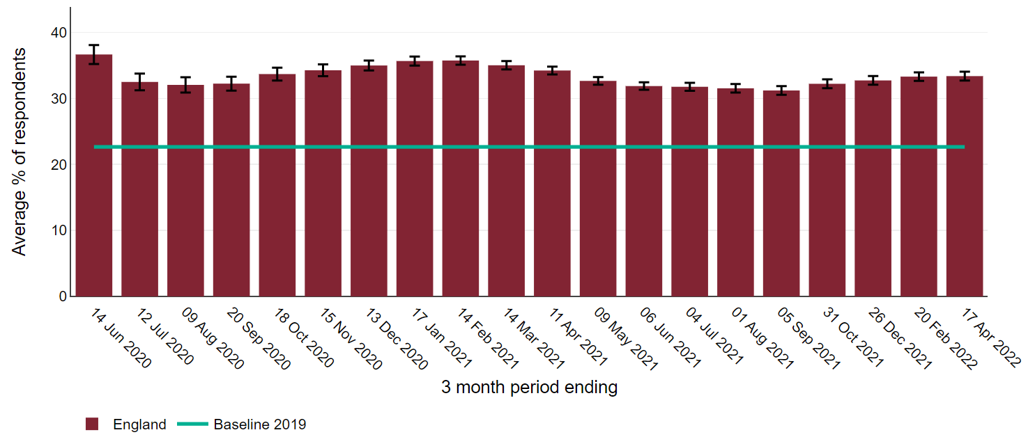
Source: OHID analysis of Opinions and Lifestyle Survey data from Office for National Statistics, 2022
Figure 10: Trend in the three-month rolling average percentage of respondents to the Opinions and Lifestyle Survey with high anxiety (score 6-10), in England by economic activity
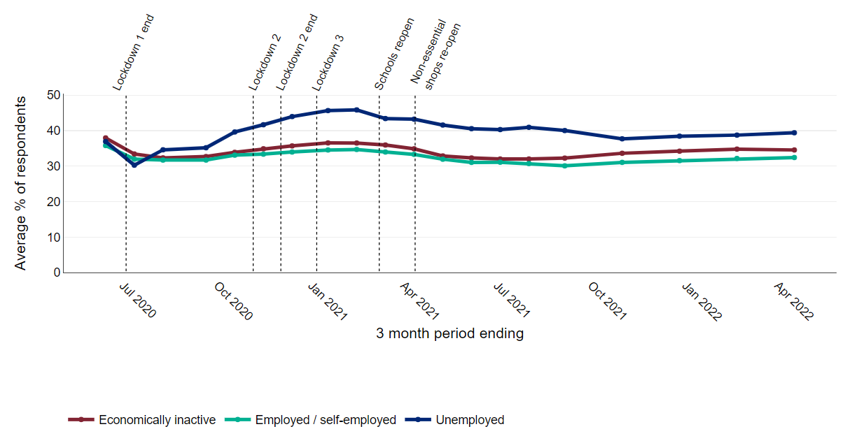
Source: OHID analysis of Opinions and Lifestyle Survey data from Office for National Statistics, 2022

Employment and Income
After remaining at a fairly constant level throughout 2018 and 2019, the number of job vacancies in the UK more than halved from 820,000 vacancies in the November 2019 to January 2020 quarter, to 367,000 in May to July 2020 when the first lockdown was in place. The number of job vacancies has risen in each quarter since this low point, surpassing the pre-pandemic level and reaching 1,295,000 vacancies in February to April 2022 (Figure 11).
Figure 11: Number of job vacancies in the UK (thousands), seasonally adjusted, from November 2017 to April 2022
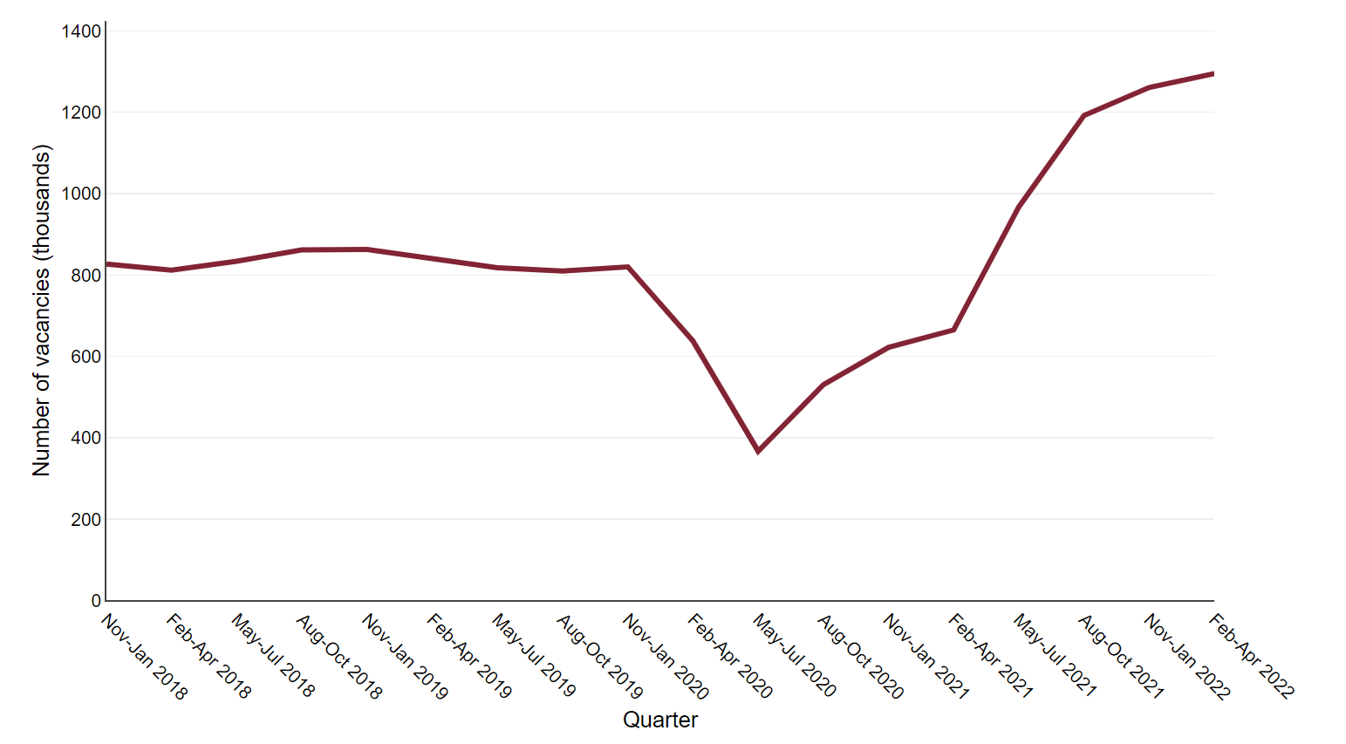
Source: Vacancy Survey, Office for National Statistics
The redundancy rate in the UK increased from 4.8 per 1,000 employees in the quarter April to June 2020 to 12.9 per 1,000 employees in the quarter October to December 2020 (Figure 12). In the following quarters the rate decreased sharply, returning to pre-pandemic levels in April to June 2021. In the most recent quarter, January to March 2022, the rate decreased to 2.5 per 1,000 employees which is below pre-pandemic levels.
Figure 12: Redundancy rate (ratio of the number of redundancies in the three months prior to interview to the number of employees) in the UK, by sex, from January 2018 to March 2022
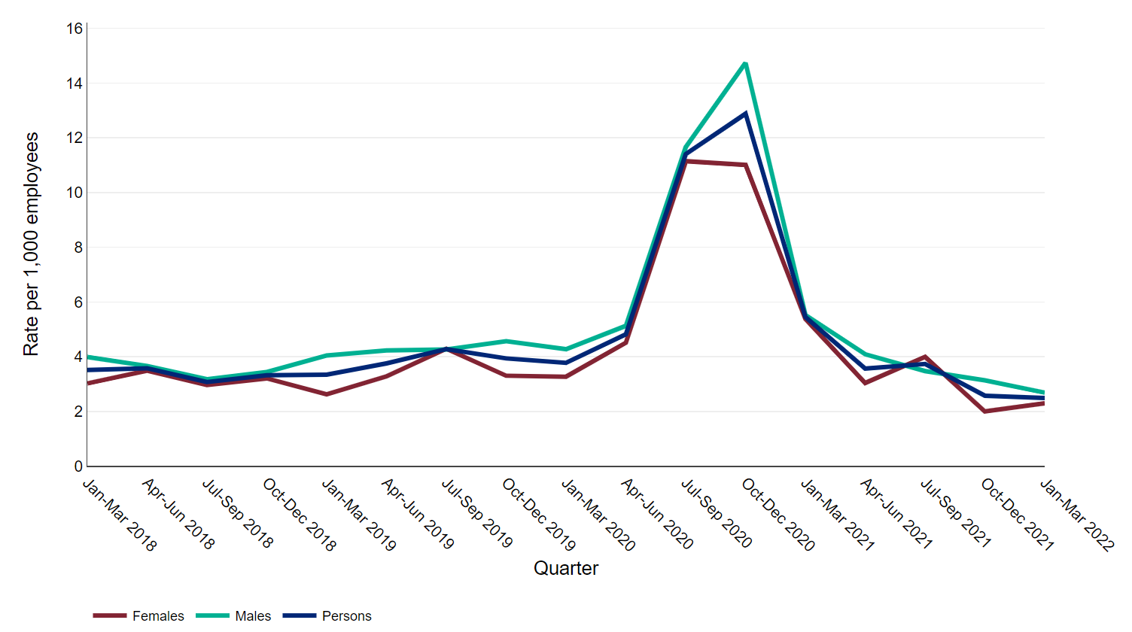
Source: Labour Force Survey, Office for National Statistics

