Wider Impacts of COVID-19 on Health (WICH) summary, 20 January 2022

Overview
This summary provides the main messages for metrics updated in this release.

Main messages
New metric: Adult asthma
Between March 2020 and July 2021, levels of asthma admissions in adults were lower than the 2018 and 2019 baseline average (Figure 1). Although still below the baseline, between April 2021 and July 2021 the admission rates were higher than for the same periods in 2020.
Figure 1: Hospital admission rate for asthma per 100,000 population aged 19 years and over, 2020 and 2021 compared with the 2018 and 2019 baseline average, England
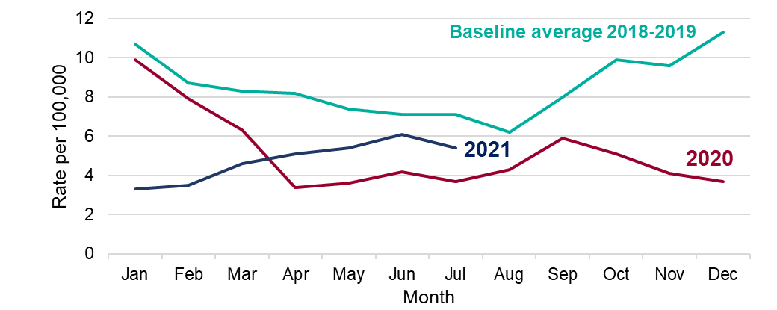

Life expectancy
Figure 2 shows that in 2020 life expectancy was lower than it had been for 5 years, for both males and females. Although still below pre-pandemic levels, provisional data for the first half of 2021 show an increase in life expectancy compared with the first half of 2020, for both males and females.

Figure 2: Life expectancy at birth, males and females, 2014 to 2021, England
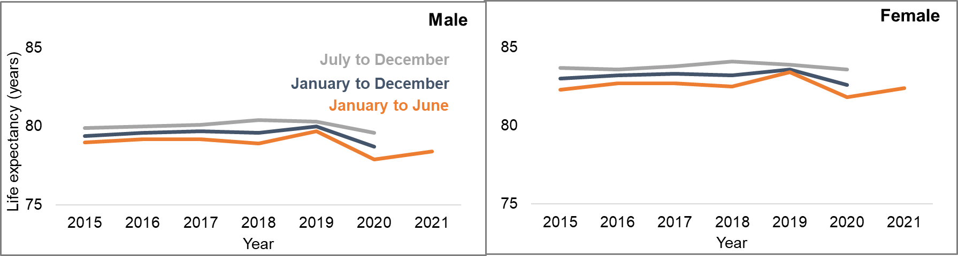

Dementia and Alzheimer’s disease
Prompt and early diagnosis of dementia enables people living with dementia, their carers and healthcare staff to plan accordingly and work together to improve health and care outcomes. The majority of diagnoses for dementia are established following a referral to a memory clinic. Primary care practitioners can refer individuals to a memory clinic if they suspect the potential for dementia.
As a consequence of the COVID-19 pandemic, referrals to memory clinics from primary care practitioners reduced in April 2020. Referral numbers remained flat until June 2021 and by November 2021 there was evidence that referrals were returning to pre-pandemic levels (Figure 3).
Figure 3: Cumulative count of referrals to memory clinics (all ages), 2017/18 to November 2021/22, England
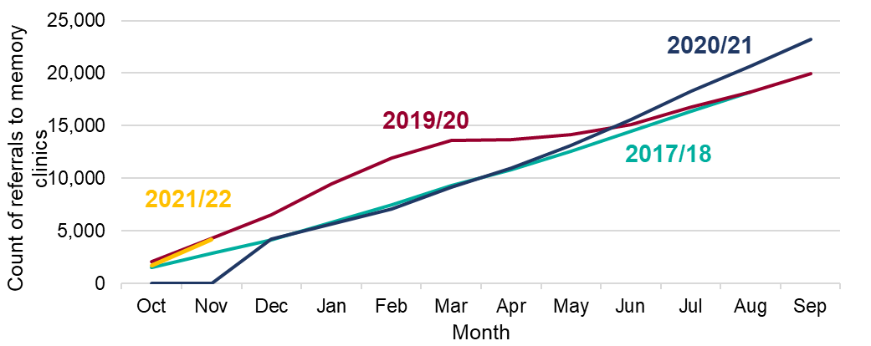

The Estimated Dementia Diagnosis Rate (EDDR) measures the number of people with a formal diagnosis of dementia as a percentage of those estimated to be living with dementia. The current aspiration is that 66.7% of people with dementia have a formal diagnosis. During wave 1 of the pandemic, the EDDR decreased to below the aspired level and has remained below since then (Figure 4).

Figure 4: Estimated dementia diagnosis rate (aged 65 and over), 2019 to November 2021, England
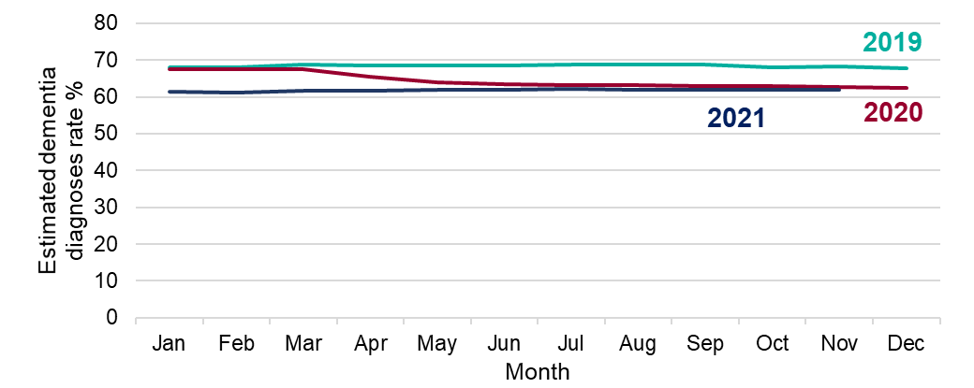Following a formal diagnosis of dementia, an individual should receive a dementia care plan that addresses their current needs. Primary care practitioners have the responsibility for managing care of people with dementia post diagnosis and this includes a Quality Outcome Framework requirement to review dementia care plans to ensure they remain contemporary to the needs of the individual. The aspiration is that 75% of dementia care plans are reviewed annually. Between March 2020 and January 2021, the percentage of care plan reviews had decreased from the aspired level to under 40% and remained at this level until September 2021 (Figure 5). By November 2021, there is evidence to suggest that dementia care plan reviews were once again being undertaken but the level remained significantly under the baseline average.
Figure 5: Percentage of those with a dementia diagnosis with care plan or care plan review in the preceding 12 months (all ages), 2018-19 to November 2021
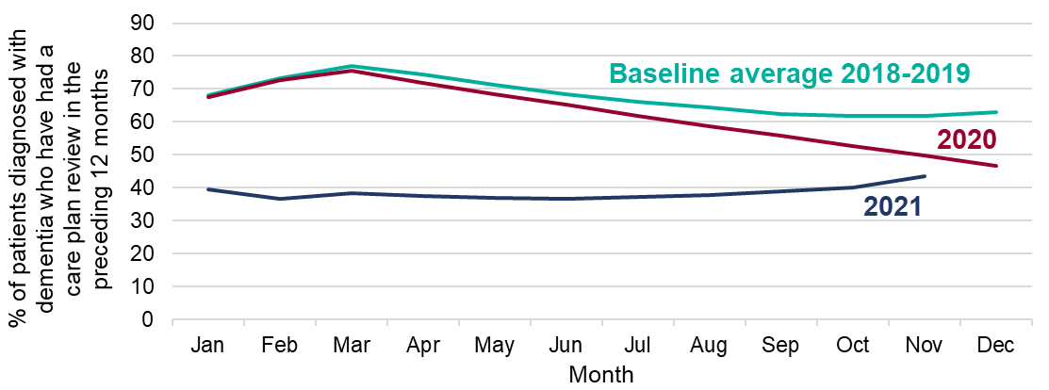
Smoking prevalence and quit attempts
There was an increase in the percentage of people attempting to quit smoking from March to June 2020 (Figure 6). After that the percentage fluctuated but remained consistently higher than 2019. From May 2021 to October 2021, the number of people attempting to quit smoking increased from 34% to over 41% of smokers.
Figure 6: Percentage of smokers in the Smoking Toolkit Study making quit attempts, 2018 to October 2021, England
