Wider Impacts of COVID-19 on Health (WICH) summary, 17 February 2022

Overview
This summary provides the main messages for metrics updated in this release.

Main messages
New metric: Child physical activity
The first national lockdown saw school sites close to most pupils and the ‘stay at home’ rule put in place for much of the Summer 2020 term. The percentage of children and young people who were active in this term was 2.3% lower than in the Summer 2019 term.
The Autumn 2020 term saw school sites reopen to all pupils, however, disruption continued with the operation of the pupil ‘bubble’ system and ad-hoc closures commonplace. Additionally, this term saw restrictions start to be reimposed. These factors all impacted activity levels, with 3.1% fewer children and young people meeting the active threshold in the Autumn 2020 term compared with the equivalent period 12 months earlier (which was pre-pandemic).
For much of the Spring 2021 term, school sites were again closed to most pupils as we entered a new national lockdown throughout January and February. While there was only a modest drop (2.5%) in the proportion of children and young people who were active compared to the Spring 2020 term, that was a period disrupted by the storms of early 2020. Overall, the proportion who were active in the Spring 2021 term was 6.5% down on the Spring 2019 term.
Similar to the Autumn 2020 term, during the Summer 2021 term school sites were mainly open to all pupils but there was continued disruption. The main difference being that restrictions were easing over the Summer 2021 term rather than being tightened, as they were in the Autumn 2020 term. Despite this, activity levels didn’t fully recover to Summer 2019 term levels.

Figure 1: Percentage of physically active children and young people in the Active Lives Survey, England
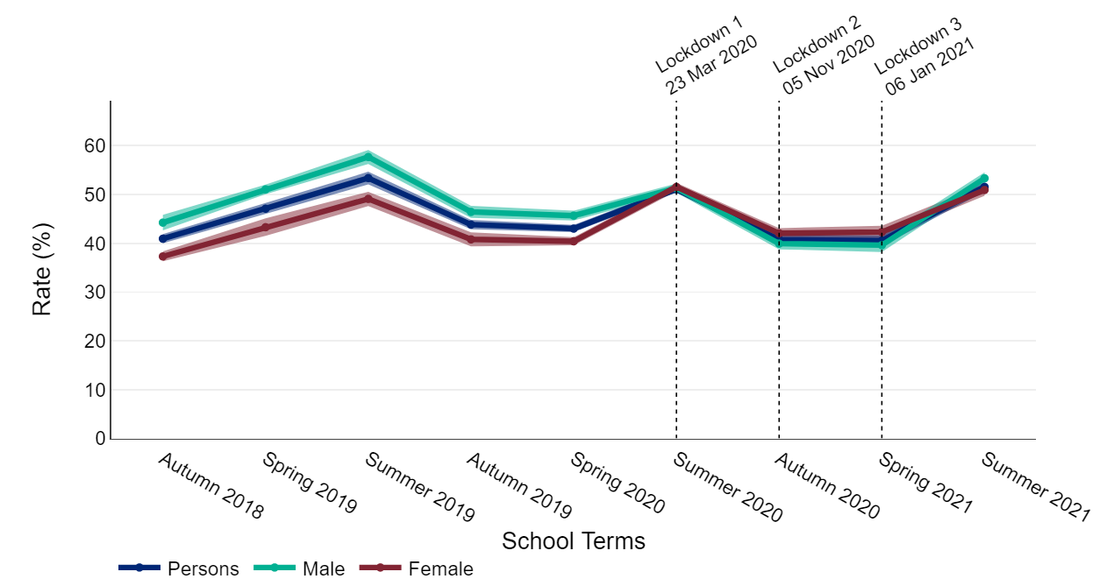

Vision healthcare appointments and treatments
The number of cataract surgeries dropped to very low levels in April 2020 and remained at a lower number than the 2018 and 2019 baseline average for the rest of 2020 (Figure 2). Since April 2021, numbers have returned to pre-pandemic levels or above.
Figure 2: Admissions to hospital for cataract surgery, 2020 and 2021 compared with the 2018 to 2019 average, England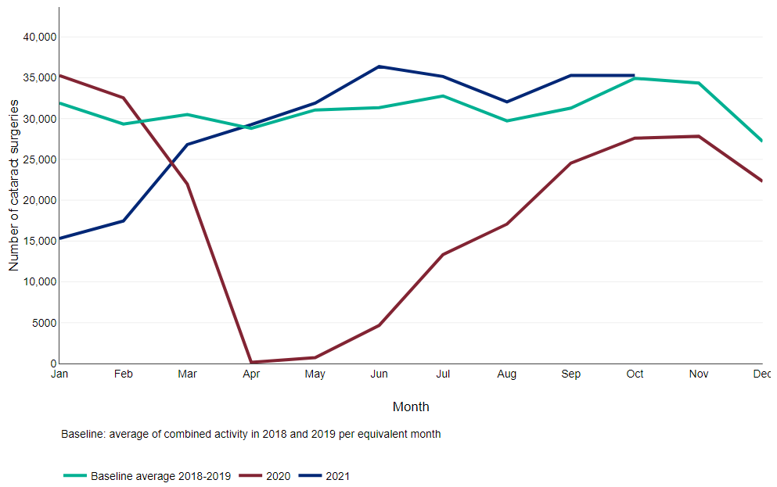
Alcohol-specific emergency admissions and mortality
The rate of emergency hospital admissions for all alcohol-specific conditions decreased in March and April 2020 (Figure 3). By June 2020 the rate had returned to pre-pandemic levels and has since remained at a similar rate to the 2018 and 2019 baseline average.
Figure 3: Monthly trend in emergency hospital admissions for all alcohol-specific conditions, 2020 and 2021 compared with 2018 to 2019 average, England

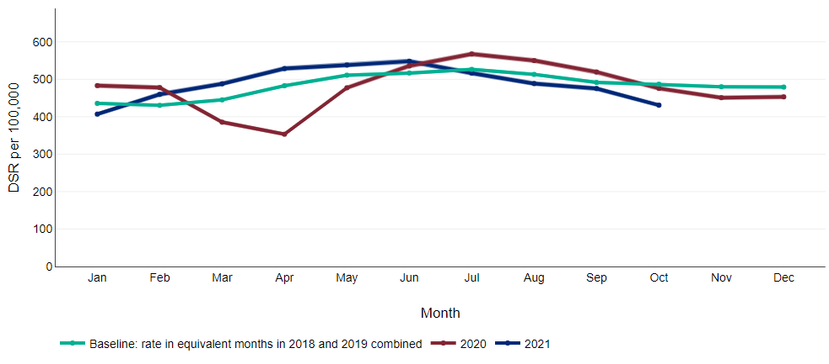
Figure 4 shows that mortality rates for alcohol-specific conditions were higher in all months from May 2020 to December 2021 than in the same months at baseline (2018 and 2019 combined).
Figure 4: Monthly trend in mortality for all alcohol-specific conditions, 2020 and 2021 compared with 2018 to 2019 average, England
