Wider Impacts of COVID-19 on Health (WICH) summary, 15 December 2022

Overview
This summary provides the main messages for some of the metrics updated in this release. It will cover the new diabetic eye screening metric and updated indicators on sexual health.

Main messages
New metrics: Diabetic eye screening
Eye screening is offered to people diagnosed with diabetes mellitus (excluding gestational diabetes) aged 12 years and older on an annual basis. Screening aims to detect damage to the back of the eye (retina) early so that it can be treated. If left undiagnosed or untreated diabetic retinopathy can cause blindness. Figure 1 shows the proportion of eligible people with diabetes offered routine digital screening (RDS) who attend a RDS event where images are captured (uptake). The data is measured across a rolling 12 month period. Between the rolling 12 month periods ending 30 June 2017 and 31 March 2020, approximately 82.3% of the eligible people with diabetes offered RDS had attended a successful screen (images captured enable a screening outcome to be determined).

Diabetic eye screening services paused screening between April and June 2020, but the full impact of the pause wasn’t seen until quarter 4 of the financial year 2020 to 2021. Prior to quarter 4 2020 to 2021 the data had included pre-pandemic data because it is measured over a rolling 12 months. Uptake has increased from quarter 1 2021 to 2022 onwards and reached 78.4% in quarter 4 2021 to 2022, which is above the acceptable threshold of 75%.

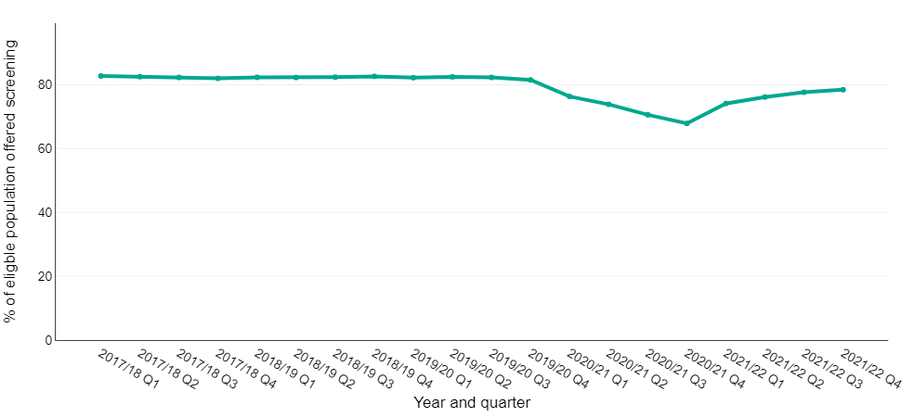
Figure 1: Proportion of those offered RDS who attend a RDS event where images are captured, April 2017 March 2022, England

Source: Screening key performance indicators, NHS England

Figure 2 shows the proportion of people with diabetes urgently referred to hospital eye services within 6 weeks of their screening or surveillance event. It is important for people with R3A retinopathy (active proliferative retinopathy) to be seen in hospital in a timely manner so that they can receive appropriate management.

The proportion was below the acceptable threshold of 80% prior to the pandemic. Between quarter 1 2017 to 2018 and quarter 3 2019 to 2020, the percentage of referrals seen on time ranged from 71.7% to 79.5%. Hospital eye services were most affected at the beginning of the pandemic when 64.2% of referrals were seen on time in quarter 4 2019 to 2020. In the most recent time period, quarter 4 2021 to 2022, 65.5% of urgent referrals were seen on time which is still below the acceptable threshold.
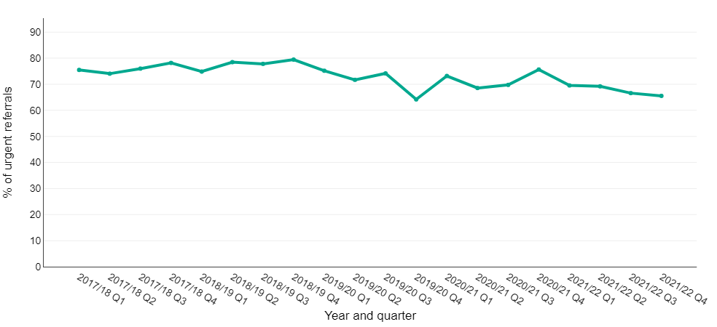
Figure 2: Proportion of people urgently referred to hospital eye services who attended within 6 weeks of their screening or surveillance event, April 2017 to March 2022, England

Source: Screening key performance indicators, NHS England

Sexual Health

Gonorrhoea

Figure 3 shows that gonorrhoea diagnoses from sexual health services with complete data in March, May and June 2022 exceeded those in the corresponding months in 2020 and 2019.

Figure 3: Number of gonorrhoea diagnoses in England, the bars compare data from sexual health services with complete data reported for January to December in 2019, 2020, 2021 and January to June 2022. The line represents the total number of diagnoses reported by all sexual health services (not only those with complete data over the time period) in each month in 2019, 2020, 2021 and 2022.

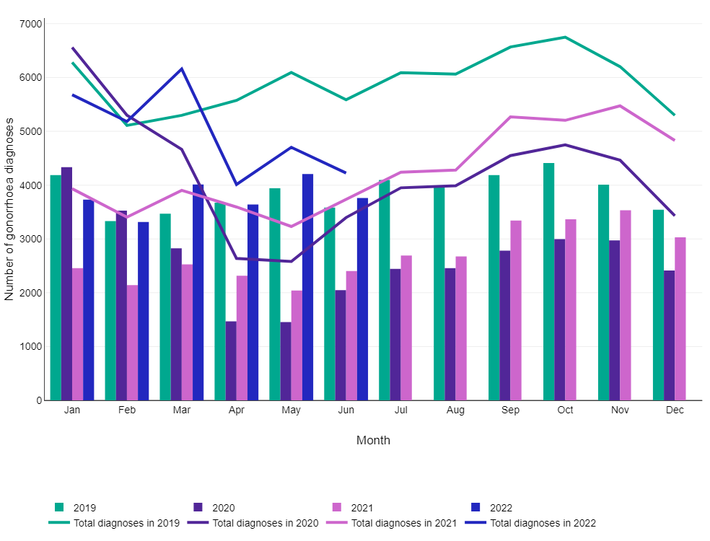
Source: GUMCAD STI Surveillance System, UK Health Security Agency (UKHSA)

The percentage of gonorrhoea diagnoses made using self-sampling kits provided by internet services in April to June 2022 is higher than that of the corresponding period in 2019 (Figure 4). This reflects the continued scale up of online self-sampling services to test for sexually transmitted infections (STIs).

Figure 4: Percentage of gonorrhoea diagnoses made in sexual health services that were diagnosed via internet testing, in England

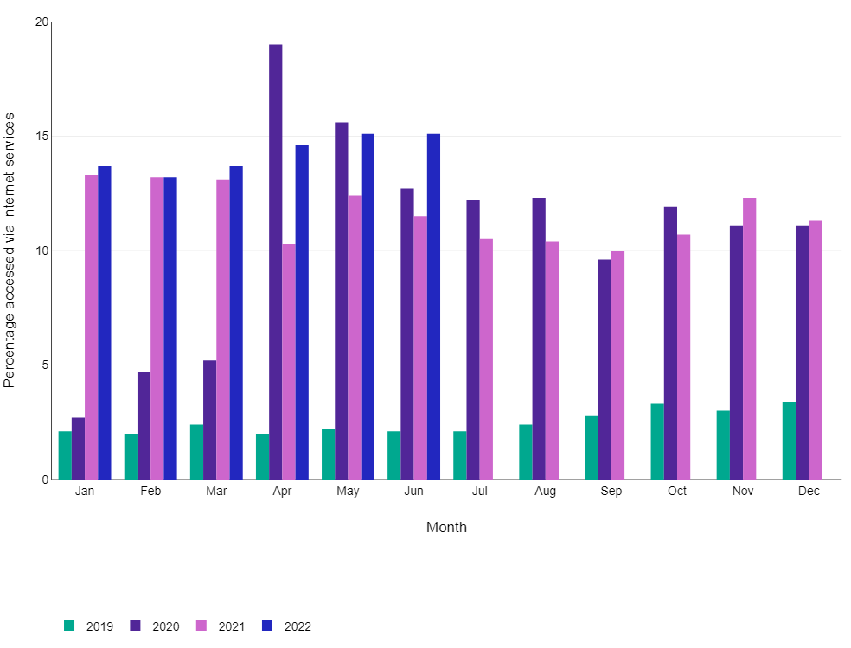
Source: GUMCAD STI Surveillance System, UK Health Security Agency (UKHSA)

Syphilis

Figure 5 shows that the number of syphilis diagnoses in sexual health services with complete data was higher in January to June 2022 compared to the corresponding period in 2019.

Figure 5: Number of syphilis diagnoses in England, the bars compare data from sexual health services with complete data. The line represents the total number of diagnoses reported by all sexual health services (not only those with complete data over the time period).

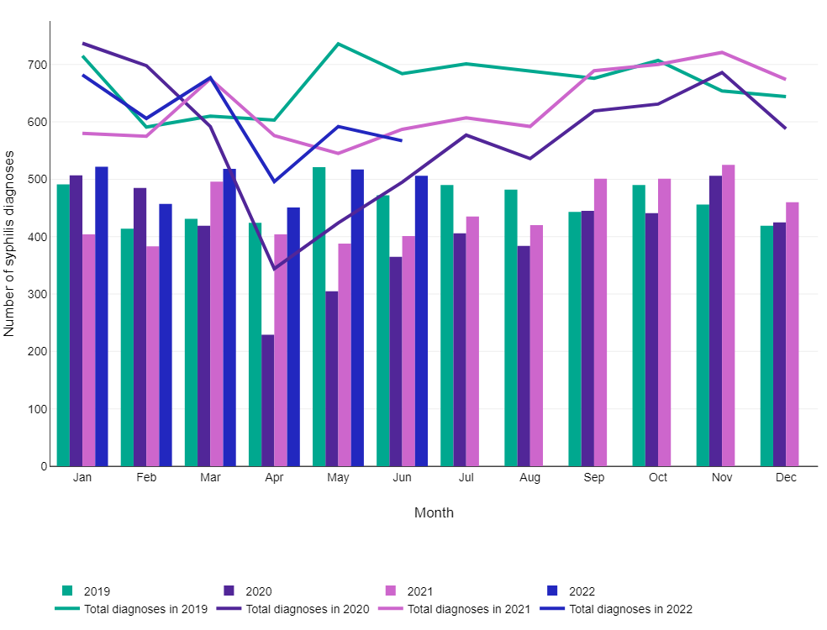
Source: GUMCAD STI Surveillance System, UK Health Security Agency (UKHSA)

Bacterial STI tests

Figure 6 shows that the monthly number of bacterial STI tests in 2022 has not returned to 2019 levels.

Figure 6: Number of bacterial STI tests (excluding chlamydia in under 25 year olds) in England by year, the bars compare data from sexual health services with complete data. The line represents the total number of diagnoses reported by all sexual health services (not only those with complete data over the time period).

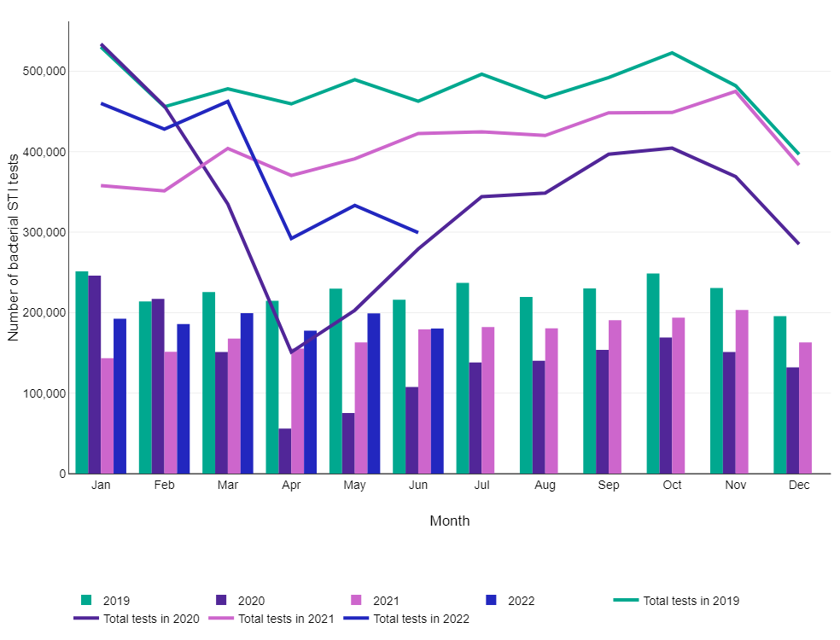
Source: CTAD and GUMCAD STI Surveillance Systems, UK Health Security Agency (UKHSA)

Figure 7 shows that the percentage of bacterial STI tests conducted using self-sampling kits provided by internet services in April to June 2022 is higher than that of the corresponding period in 2019. This reflects the continued scale up of online self-sampling services to test for STIs.

Figure 7: Percentage of bacterial STI tests (excluding chlamydia in under 25 year olds) in England by year

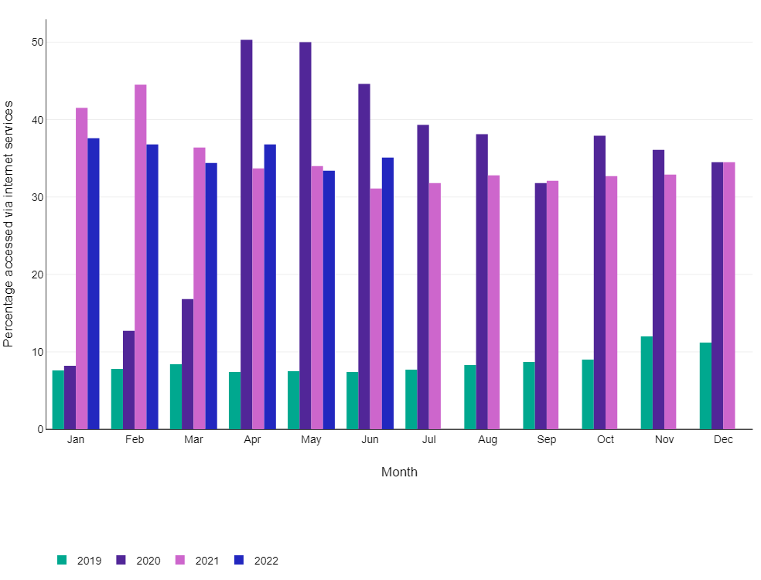
Source: CTAD and GUMCAD STI Surveillance Systems, UK Health Security Agency (UKHSA)

The proportion of bacterial STI tests among gay, bisexual and other men who have sex with men (GBMSM) steadily increased between 2019 and 2022 (Figure 8).

Figure 8: Percentage of bacterial STI tests (excluding chlamydia in under 25 year olds) in England, by sexual orientation

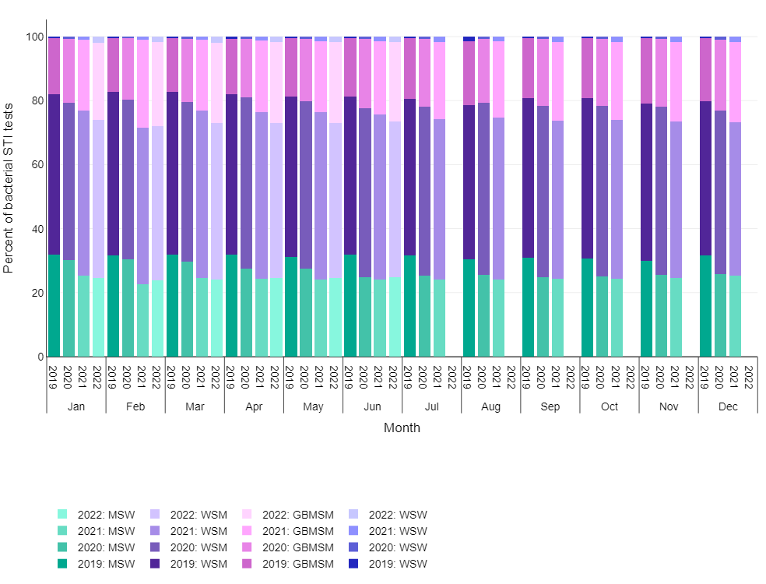
Chart note:
MSW Heterosexual men who have sex with women
WSM Heterosexual and bisexual women who have sex with men
GBMSM Gay, bisexual and other men who have sex with men
WSW Lesbians and other women who have sex with women

Source: CTAD and GUMCAD STI Surveillance Systems, UK Health Security Agency (UKHSA)

Chlamydia

Figure 9 shows that the number of chlamydia tests in 15 to 24 year olds was lower in January to June 2022 compared to the corresponding period in 2019.

Figure 9: Number of chlamydia tests in 15 to 24 year olds at sexual health services

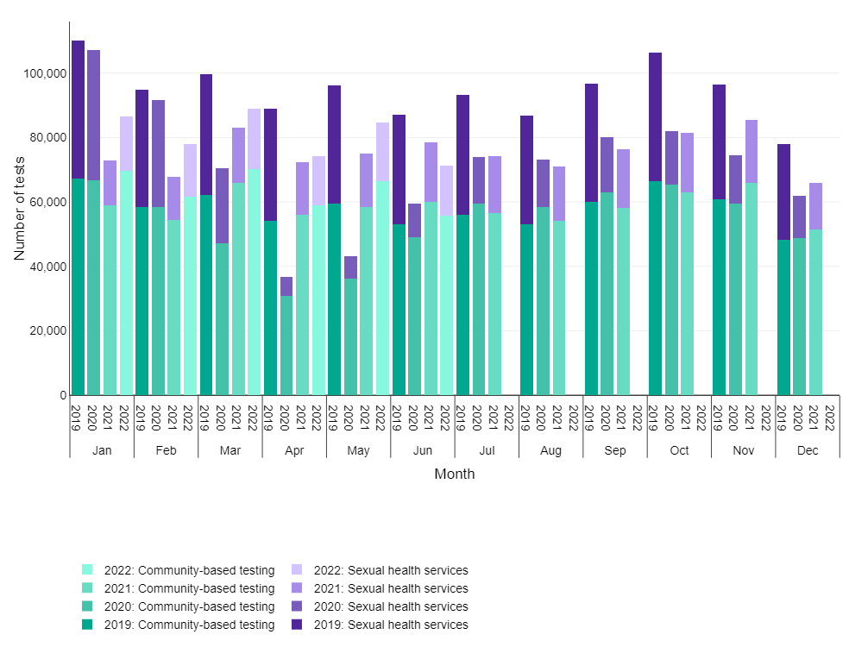
Chart note:
Sexual health services (SHSs) include both specialist (level 3) and non-specialist (level 1 & 2) SHSs. Specialist SHSs refers to genitourinary medicine (GUM) and integrated GUM/sexual and reproductive health (SRH)
Community based testing refers to young people’s services, online sexual health services, termination of pregnancy services, pharmacies, outreach and general practice, and other community-based settings.

Source: CTAD and GUMCAD STI Surveillance Systems, UK Health Security Agency (UKHSA)

Between January 2019 and February 2020, specialist sexual health services (SHS) were the most common provider of chlamydia tests in 15 to 24 year olds (Figure 10). In March 2020 that changed to internet services, which have remained the most common provider up to the most recent month of data in June 2022.

Figure 10: Percentage of chlamydia tests in 15 to 24 year olds in England, by testing service type

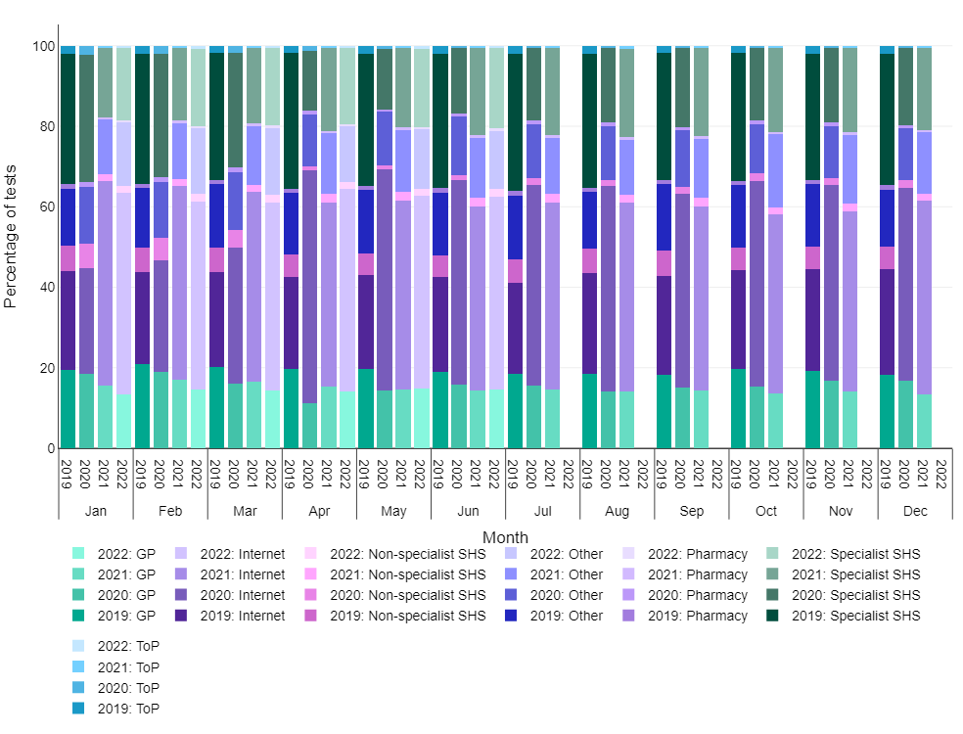
Chart note:
GP – general practice
Internet – self-sampling kits provided by internet services
Non-specialist SHS – level 1 and 2 sexual health services
Other – other community-based settings
Pharmacy - pharmacies
Specialist SHS - specialist sexual health services refer to genitourinary medicine (GUM) and integrated GUM/sexual and reproductive health (SRH)
ToP - termination of pregnancy centres

Source: CTAD and GUMCAD STI Surveillance Systems, UK Health Security Agency (UKHSA)

