Wider Impacts of COVID-19 on Health (WICH) summary, 16 December 2021

Overview
This summary provides the main messages for metrics updated with data.
Main messages
Life expectancy
The chart below shows that 2020 life expectancy was lower for both men and women than it had been for 5 years. Although still below pre-pandemic levels, provisional data for the first half of 2021 show an increase in life expectancy compared with the first half of 2020 for both men and women.
Figure 1: Life expectancy at birth, for males and females, from 2001 to 2020, in England
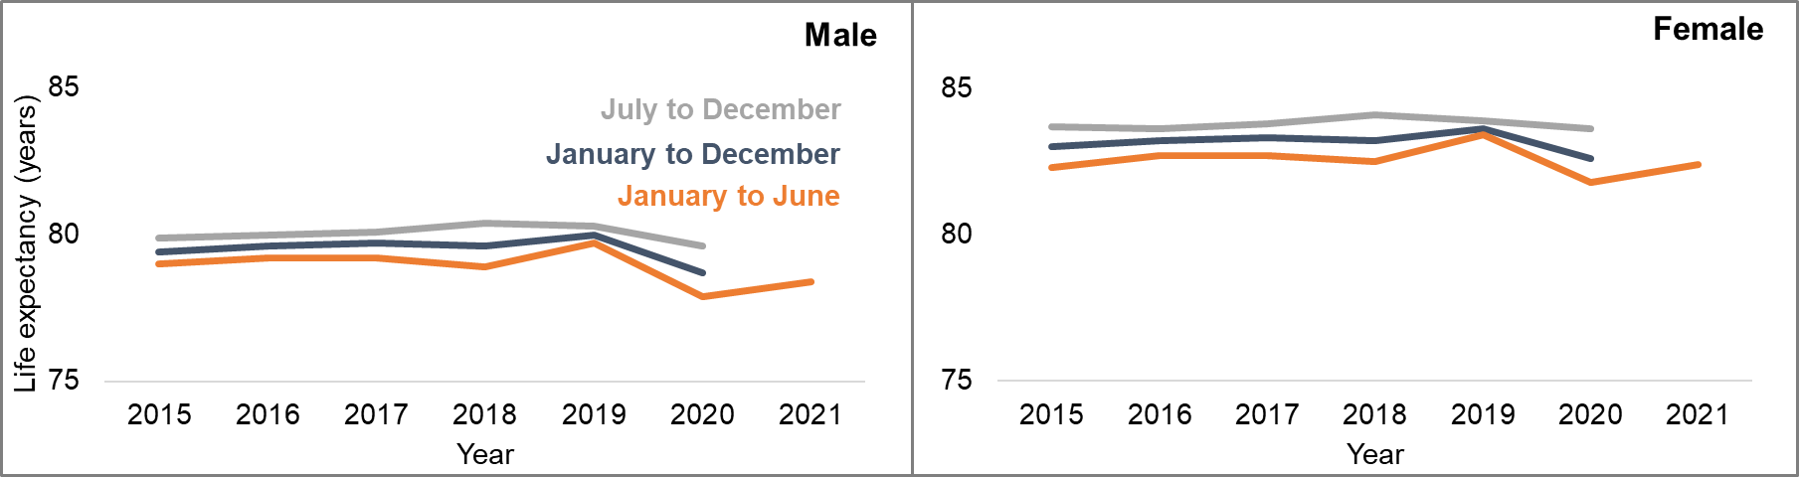
Hospital activity in children and young people
In children and young people, rates of hospital admissions during the pandemic, from April to December 2020 were generally below the average rates in 2018 and 2019 for equivalent months.
Figure 2: Monthly trend in hospital admission rate per 100,000 population for bronchiolitis in 2020 and 2021 compared with 2018 and 2019 baseline average in 0 to 1 year olds in England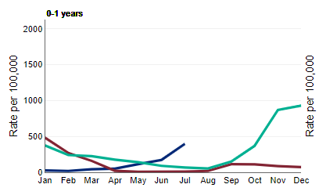
Between March 2020 to May 2021, levels of bronchiolitis admissions were lower than the comparison baseline. In June 2021 levels of admission were above the baseline. This off-season rise in infections has been attributed to the reduced levels of infection during 2020 and early 2021 resulting in a lower level of immunity.

Employment
Figure 3: Trend in proportion of resident population
aged 16 to 64 claiming unemployment benefits by sex from January 2019 to October 2021 in England
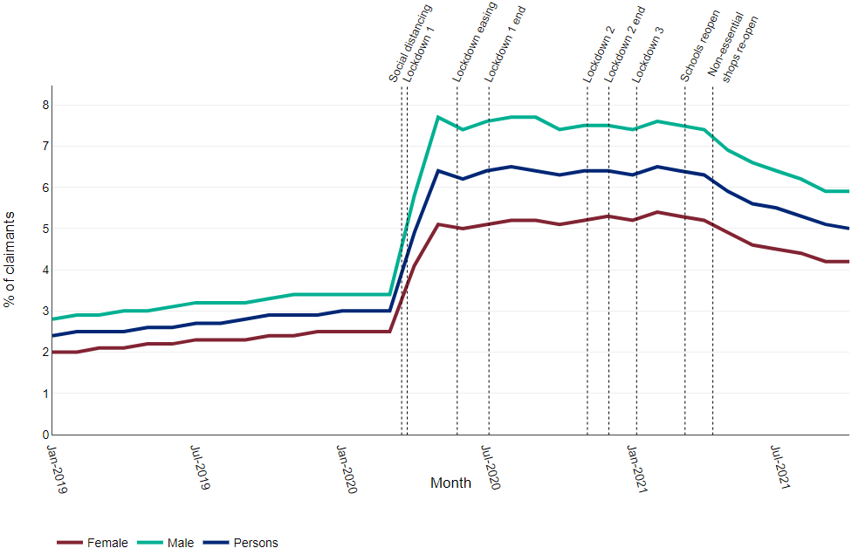
The proportion of people claiming unemployment benefits more than doubled between March 2020 and May 2020. The proportion of claimants decreased from April to October 2021 whilst remaining above pre-pandemic levels.

Alcohol consumption and related mortality
There was an increase in the proportion of ‘increasing and higher risk’ drinkers from April to June 2020. After that the proportion declined slightly but remained consistently higher than 2019. From April 2021 to October 2021, following the ending of most social restrictions and the opening of non-essential shops, the proportion of ‘increasing and higher’ risk drinkers increased again.

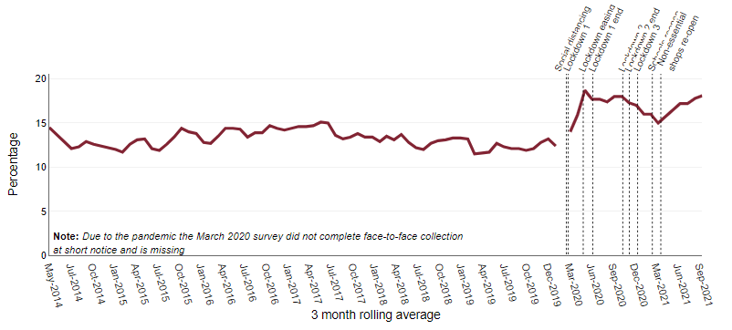
Figure 4: Trend in prevalence of increasing and higher risk drinking, from May 2014 to October 2021 in England

Mortality rates for alcohol-specific conditions were higher for all months from May 2020 to September 2021 than in the same months at baseline (2018 and 2019 combined).
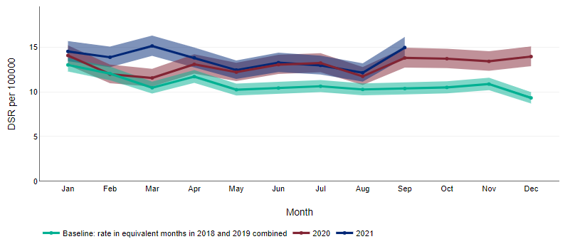
Figure 5: Monthly trend in mortality per 100,000 population for all alcohol-specific conditions in England

