Wider Impacts of COVID-19 on Health (WICH) summary, 21 April 2022

Overview
This summary provides the main messages for some of the metrics updated in this release. It will cover the neurological care metrics, including outpatient and telephone neurologist appointments, and smoking prevalence. Other updated themes not discussed include vision, dementia and Alzheimer’s disease and alcohol.
Main messages
Neurological care
Neurology is generally a tertiary special service, with the majority of activity undertaken through either elective outpatient consultations or non-elective hospital clinical referrals. Since the end of the first wave of the pandemic (June 2020) specialist neurological outpatient services have been functioning near to the baseline trend of 2019 (Figure 1), with an approximate 2% increase in appointments undertaken by the end of 2021 (Figure 2).
Figure 2 shows that the increase in activity between 2019 and 2021 was driven by larger demand for appointments from people aged 20 to 39 years of age (6.4% increase) and those over 75 years (5.7% increase). However, the number of appointments for those aged 65 to 74 years decreased by 1.6% on the 2019 baseline.
Figure 1: Rate of outpatient neurologist consultant appointments per 100,000 population (aged 20 years and over)
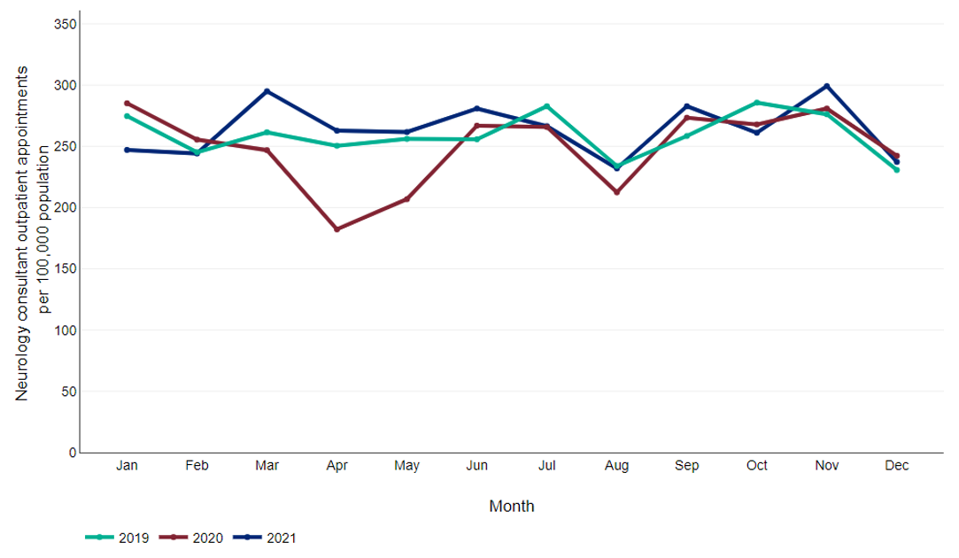
Figure 2: Percentage change in outpatient appointments by age group for 2021 compared to 2019 baseline
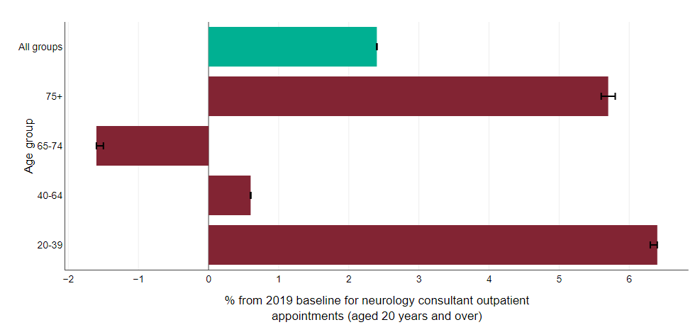
Appointments for those in the Chinese and White ethnic groups decreased between 2019 and 2021, while appointments for all other groups increased by between 1.1% to 17.3% (Figure 3).
Figure 3: Percentage change in outpatient appointments by ethnic group for 2021 compared to 2019 baseline
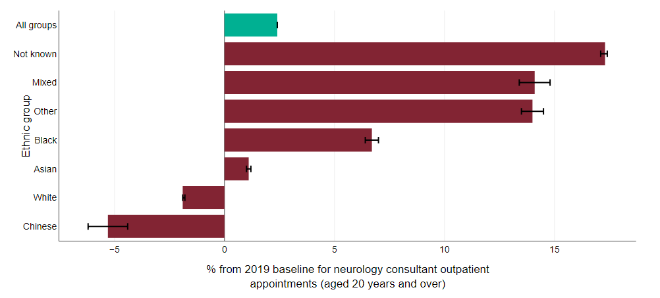
The relatively high levels of appointments delivered during the pandemic period by specialist neurological outpatient services have been possible due to the use of non-face-to-face appointments, recorded in the data source as telephone consultations. By the end of the first wave of the pandemic the proportion of subsequent appointments being provided in a non-face-to-face way had risen to 58.4%. This mode of delivery has remained above 45% of all neurology outpatients since April 2020. Studies are currently evaluating the effectiveness of this mode of service delivery.

Figure 4: Percentage of subsequent neurology consultant outpatient appointments delivered by telephone (aged 20 years and over)
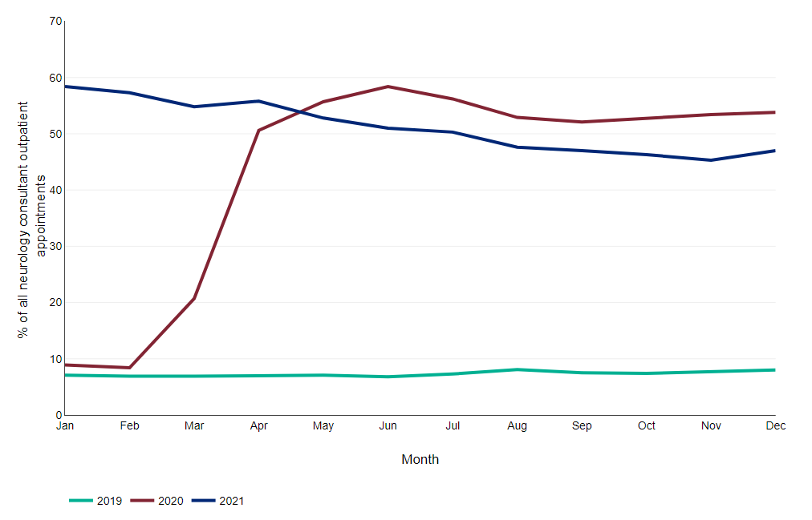

Smoking prevalence
The Smoking Toolkit Study is a monthly household survey, which each month involves a new representative sample of between 1,700 and 1,800 adults. Figure 5 shows that between February 2020 and February 2022, the percentage of current cigarette smokers in the Smoking Toolkit Study remained between 13.4% and 15.4%.

Figure 5: Percentage of current cigarette smokers in the Smoking Toolkit Study, in England
