Wider Impacts of COVID-19 on Health (WICH) summary, 15 September 2022

Overview
This summary provides the main messages for some of the metrics updated in this release. It will cover the updated indicators on alcohol-specific hospital admissions, NHS Health Checks, benefits, employment and income.

Main messages
Alcohol-specific hospital admissions
In this release, metrics on alcohol-specific emergency admissions have been revised to enable better interpretation of the impact of the pandemic. Data from Hospital Episode Statistics (HES) has been grouped into broader quarterly time periods to assess trends.
Figure 1 shows that in the third quarter of 2020, the directly age-standardised rate (DSR) of emergency hospital admissions for alcoholic liver disease per 100,000 increased to 14.5% above the baseline level (the equivalent quarter in 2018 and 2019 combined). The DSR remained above pre-pandemic levels throughout the rest of 2020 and all of 2021.
Figure 1: Quarterly trend in emergency hospital admissions for alcoholic liver disease in England
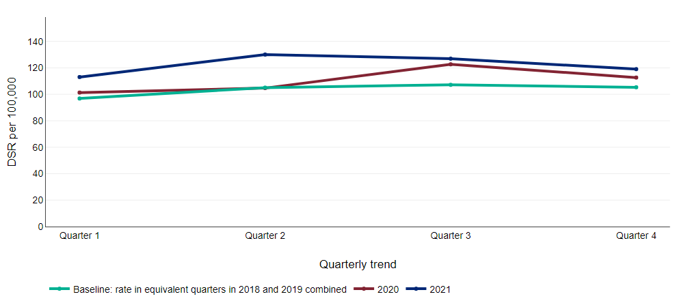
Source: Hospital Episode Statistics (HES), Copyright © 2021, Re‐used with the permission of NHS Digital. All rights reserved

In contrast to alcoholic liver disease, the DSR in emergency hospital admissions for alcohol poisoning per 100,000 decreased to 13.8% below the baseline level in quarter 4 of 2020 (Figure 2). The DSR has remained significantly lower than the baseline level throughout 2021.

Figure 2: Quarterly trend in emergency hospital admissions for alcohol poisoning in England
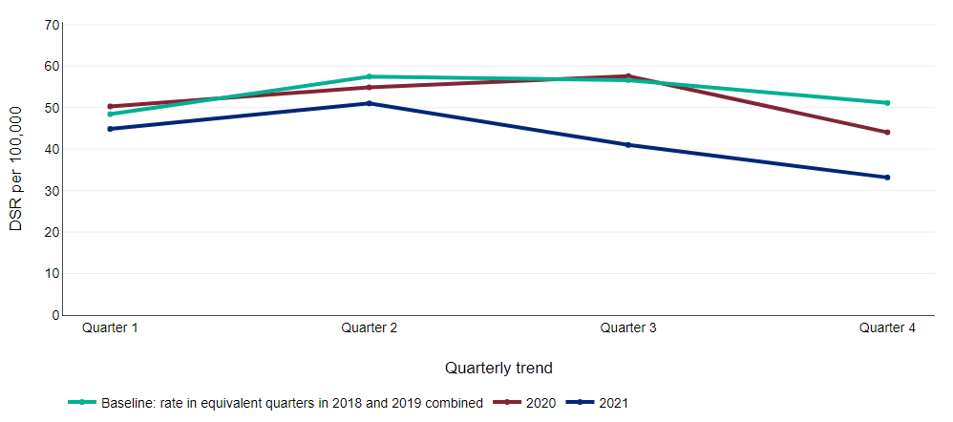
Source: Hospital Episode Statistics (HES), Copyright © 2021, Re‐used with the permission of NHS Digital. All rights reserved

NHS Health Checks
The NHS Health Check programme aims to prevent heart disease, stroke, diabetes and kidney disease, and some cases of dementia among adults aged 40 to 74 years who do not have an existing diagnosis of cardiovascular disease. Local areas are required to offer a check to all eligible people over a five year period. To meet this requirement, it is expected that about 5% of eligible people are invited for a check each quarter.

Figure 3: Percentage of NHS Health Checks received by the total eligible population in the quarter
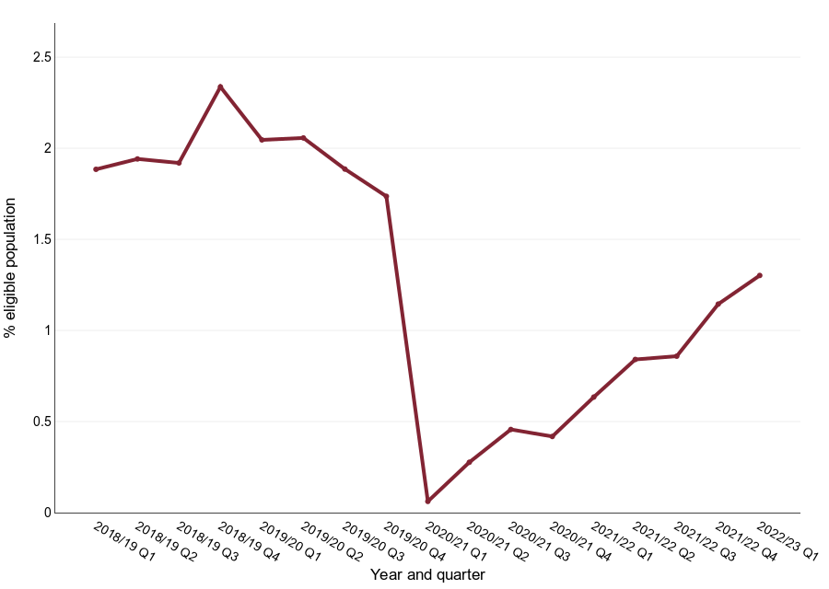
Source: Local authorities collect information on the number of NHS Health Checks offered and the number of NHS Health Checks received each quarter and return this data to OHID

Figure 3 shows the proportion of eligible people who have had an NHS Health Check each quarter since 2018 to 2019. It illustrates that the number of people having a check dropped in 2020 to 2021 and that the number of checks carried out in Quarter 1 of 2022 to 2023 was the highest since the start of the pandemic.
Delivery of the programme, which is commissioned by local government and provided mainly in NHS primary care settings, was largely suspended between April 2020 and February 2022 because of the pandemic and in line with national guidance from NHS England. Local areas are making good progress with recovering the service although activity is still around a third lower than that reported prior to COVID-19.

Employment and Income
After remaining at a fairly constant level throughout 2018 and 2019, the number of job vacancies in the UK more than halved from 820,000 vacancies in the November 2019 to January 2020 quarter, to 367,000 in May to July 2020 when the first lockdown was in place. The number of job vacancies increased in each quarter since this low point, surpassing the pre-pandemic level and reaching 1,294,000 vacancies in February to April 2022. In the most recent quarter the number of job vacancies decreased for the first time in the two years since the low point in May to July 2020, but remains at a higher level than pre-pandemic (Figure 4).
Figure 4: Number of job vacancies in the UK (thousands), seasonally adjusted
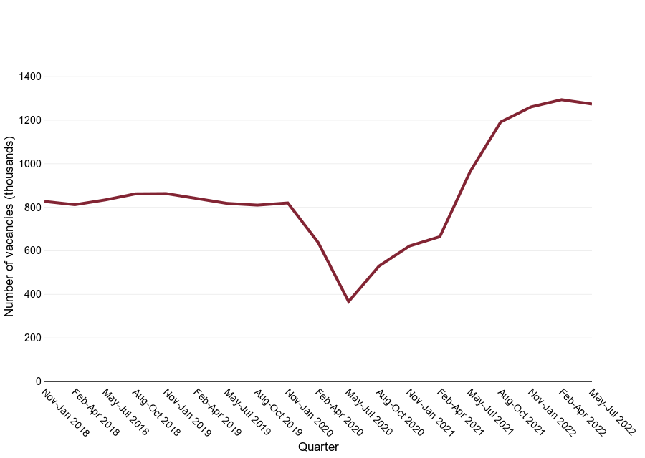
Source: Vacancy Survey, Office for National Statistics

The proportion of people claiming unemployment benefits more than doubled from 2.9% to 6.4% between March and May 2020 and remained at a high level until the end of the national lockdown restrictions in 2021 (Figure 5). Since April 2021 the proportion of people claiming unemployment benefits has decreased each month, plateauing at 3.8% from March 2022 to the latest time point in May 2022.

Figure 5: Trend in proportion of resident population aged 16-64 claiming unemployment benefits (seasonally adjusted) in England, by sex
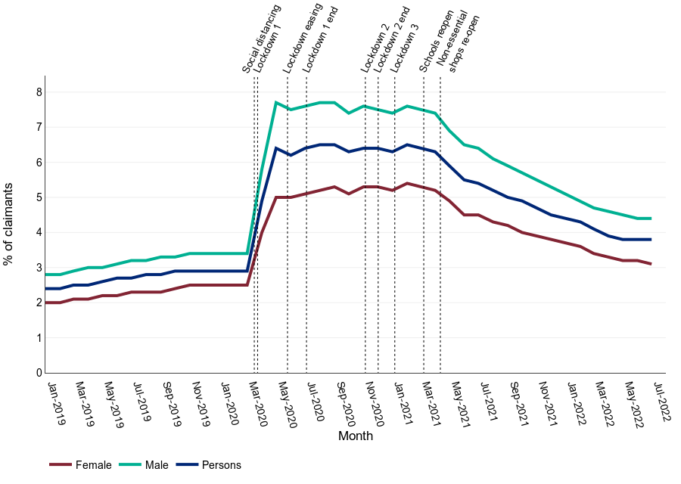
Source: Office for National Statistics

