Wider Impacts of COVID-19 on Health (WICH) summary, 21 July 2022

Overview
This summary provides the main messages for some of the metrics updated in this release. It will cover the new indicators on mortality, as well as the updated indicators on NHS Health Checks and screening (Abdominal Aortic Aneurysm (AAA) screening and breast cancer screening).

Main messages
New Indicators: Mortality
These indicators show recent trends for leading causes of death, from 2015 to 2021, by sex and area deprivation decile. Data for 2021 are provisional.
Figure 1 shows the directly age-standardised mortality rate per 100,000 population, for deaths from all causes, in England. There was a clear increase during the pandemic. Compared with 2019, in 2020 the rate for persons was 14% higher, and in 2021 it was 10% higher.
For cirrhosis and other diseases of the liver, rates were significantly higher in 2021 than 2019 for both sexes. For heart disease, rates in 2021 were higher than 2019 for all persons and males, and were similar for females.
For all the other leading causes presented (except COVID-19) rates in 2021 were either lower or not significantly different from 2019.
Figure 1: Directly age-standardised mortality rate per 100,000 population, for deaths due to all causes, in England, all ages
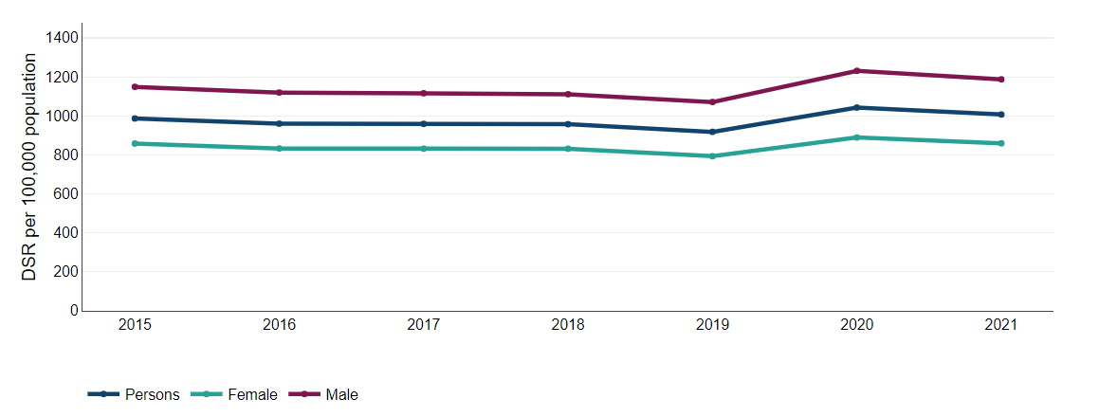 Source: Figures calculated by Office for Health Improvement and Disparities using mortality data and population estimates from the Office for National Statistics (ONS)
With the exception of deaths due to leukaemia and lymphomas, there is a deprivation gradient for the leading causes of death presented. Mortality rates generally increased as the level of deprivation increased.
The extent of these inequalities varies by cause of death. In 2021, the all-cause mortality rate for the most deprived areas in England was double the rate for the least deprived, but inequality was wider for some causes. For deaths from chronic lower respiratory disease, the mortality rate in the most deprived areas in 2021 was 4.6 times the rate in the least deprived (see Figure 2), and for cirrhosis and other diseases of the liver, the rate in the most deprived was 3.7 times that in the least deprived.
Inequality was narrower for female deaths from breast cancer and male deaths from prostate cancer. Compared with the least deprived, in 2021 the rate in the most deprived areas was 1.2 times higher for breast cancer and 1.1 times higher for prostate cancer.
Figure 2: Directly age-standardised mortality rate per 100,000 population, for deaths due to chronic lower respiratory diseases, in England, by deprivation decile within England, all ages
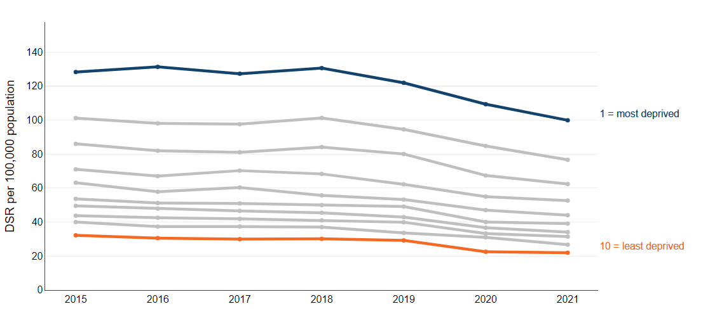
Source: Figures calculated by Office for Health Improvement and Disparities using mortality data and population estimates from the Office for National Statistics (ONS), Index of Multiple Deprivation (IMD) 2019 scores from the Department for Levelling Up, Housing and Communities

NHS Health Check
The NHS Health Check programme aims to prevent heart disease, stroke, diabetes and kidney disease, and some cases of dementia among adults aged 40 to 74 years who do not have an existing diagnosis of cardiovascular disease. Local areas are required to offer a check to all eligible people over a 5 year period. To meet this requirement, it is expected that about 5% of eligible people are invited for a check each quarter.
Figure 3: Percentage of NHS Health Checks received by the total eligible population in the quarter
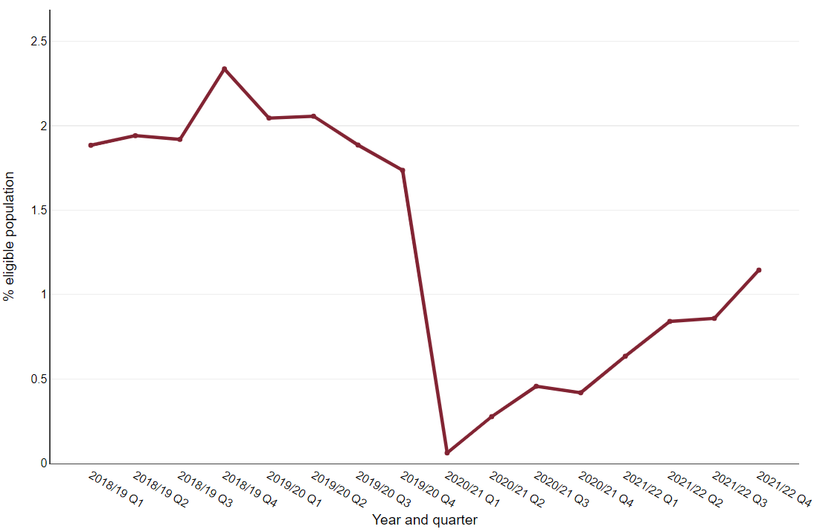

Figure 3 shows the proportion of eligible people who have had an NHS Health Check each quarter since 2018 to 2019. It illustrates that the number of people having a check dropped in 2020 to 2021 and had not fully recovered by March 2022. Delivery of the programme, which is commissioned by local government and provided mainly in NHS primary care settings, was largely suspended between April 2020 and February 2022 because of the pandemic and in line with national guidance from NHS England. Although the number of checks provided in 2021 to 2022 was less than half the yearly average reported in the three years prior to the pandemic, local areas are making good progress with recovering the service.

Screening
Abdominal aortic aneurysm (AAA)

Figure 4 shows the proportion of eligible cohort men who were screened for an AAA. Men who turn 65 in the screening year (April to the March of the following year) and haven’t had previous AAA surgery are offered a one-off ultrasound scan. The data are cumulative across the screening year. By the end of quarter 4 in 2017 to 2018, 2018 to 2019 and 2019 to 2020, approximately 77% of eligible men were screened, compared with 42.4% in 2020 to 2021.

For the 2021 to 2022 cohort year, performance continues to improve compared with the 2020 to 2021 screening year. By the end of December 2021, 35.9% of the eligible cohort had been screened, compared with 23.7% at the end of December 2020. However, this is still below the performance of approximately 62%, which was achieved at the end of December in the three years prior to the pandemic.

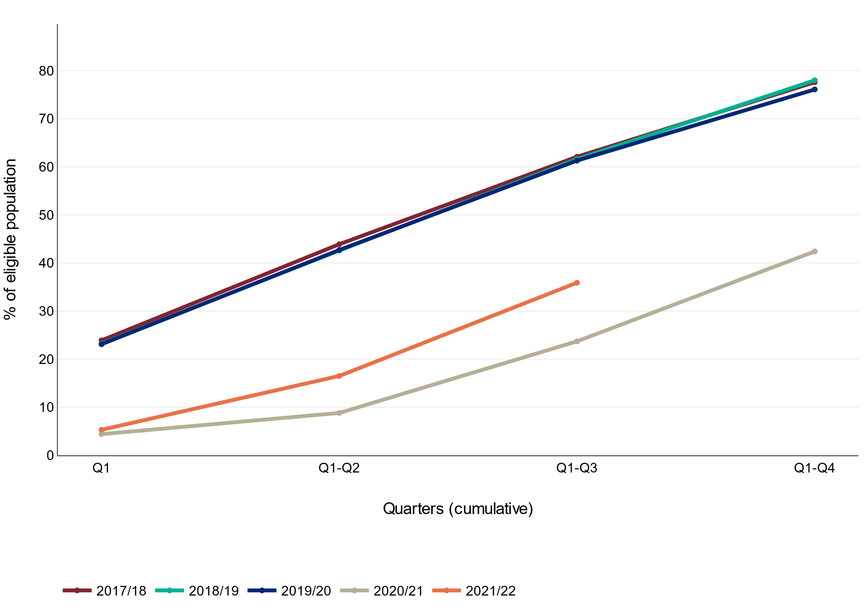
Figure 4: Proportion of eligible cohort men who were screened for an abdominal aortic aneurysm, April 2017 to December 2021, England

Source: Screening key performance indicators, NHS England and NHS Improvement

Figure 5 shows the proportion of annual surveillance appointments for AAA where there is a conclusive scan within 6 weeks of when the appointment is due each quarter (coverage). The annual surveillance scan is for men who are found to have a small aneurysm (aorta measures 3.0 to 4.4cm on ultrasound scan) at their initial screen (includes cohort men aged 65 and men aged over 65 who have self-referred). An annual surveillance scan is offered until the aneurysm reaches 5.5cm, when they are referred for treatment. Prior to the pandemic about 93% of appointments had a conclusive screen in the timeframe.

Coverage fell to a low of 57.4% in quarter 1 2021 to 2022. This is mainly a reflection of the fact that very few men were due an appointment in this quarter, as screening was paused for the same quarter in the previous year. For quarter 2 and quarter 3 2021 to 2022 performance has been 92.4% and 91.5% respectively. This is similar to the performance for the same quarters in 2017 to 2018 and 2018 to 2019.

Figure 5: Proportion of annual abdominal aortic aneurysm surveillance appointments due where there is a conclusive scan within 6 weeks either side of the due date, April 2017 to December 2021, England
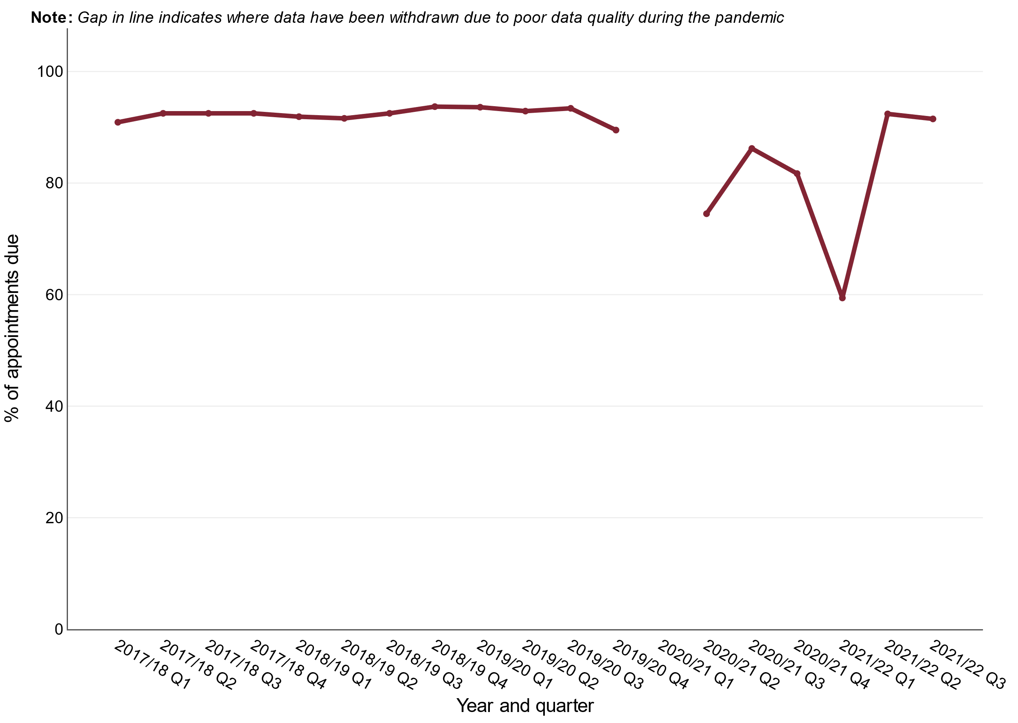
Source: Screening key performance indicators, NHS England and NHS Improvement

Figure 6 shows the proportion of quarterly surveillance appointments for AAA where there is a conclusive scan within 4 weeks of when the appointment is due each quarter (coverage). The quarterly surveillance scan is for men who are found to have a medium aneurysm (aorta measures 4.5 to 5.4cm on ultrasound scan) at their initial screen (includes cohort men aged 65 and men aged over 65 who have self-referred) or at their annual surveillance scan. Prior to the pandemic about 93% of appointments had a conclusive screen in the timeframe.

Coverage of the quarterly surveillance scan has been approximately 93% for the first three quarters of 2021 to 2022, which is similar to pre-pandemic levels. This aspect of AAA screening appears to be recovering well.

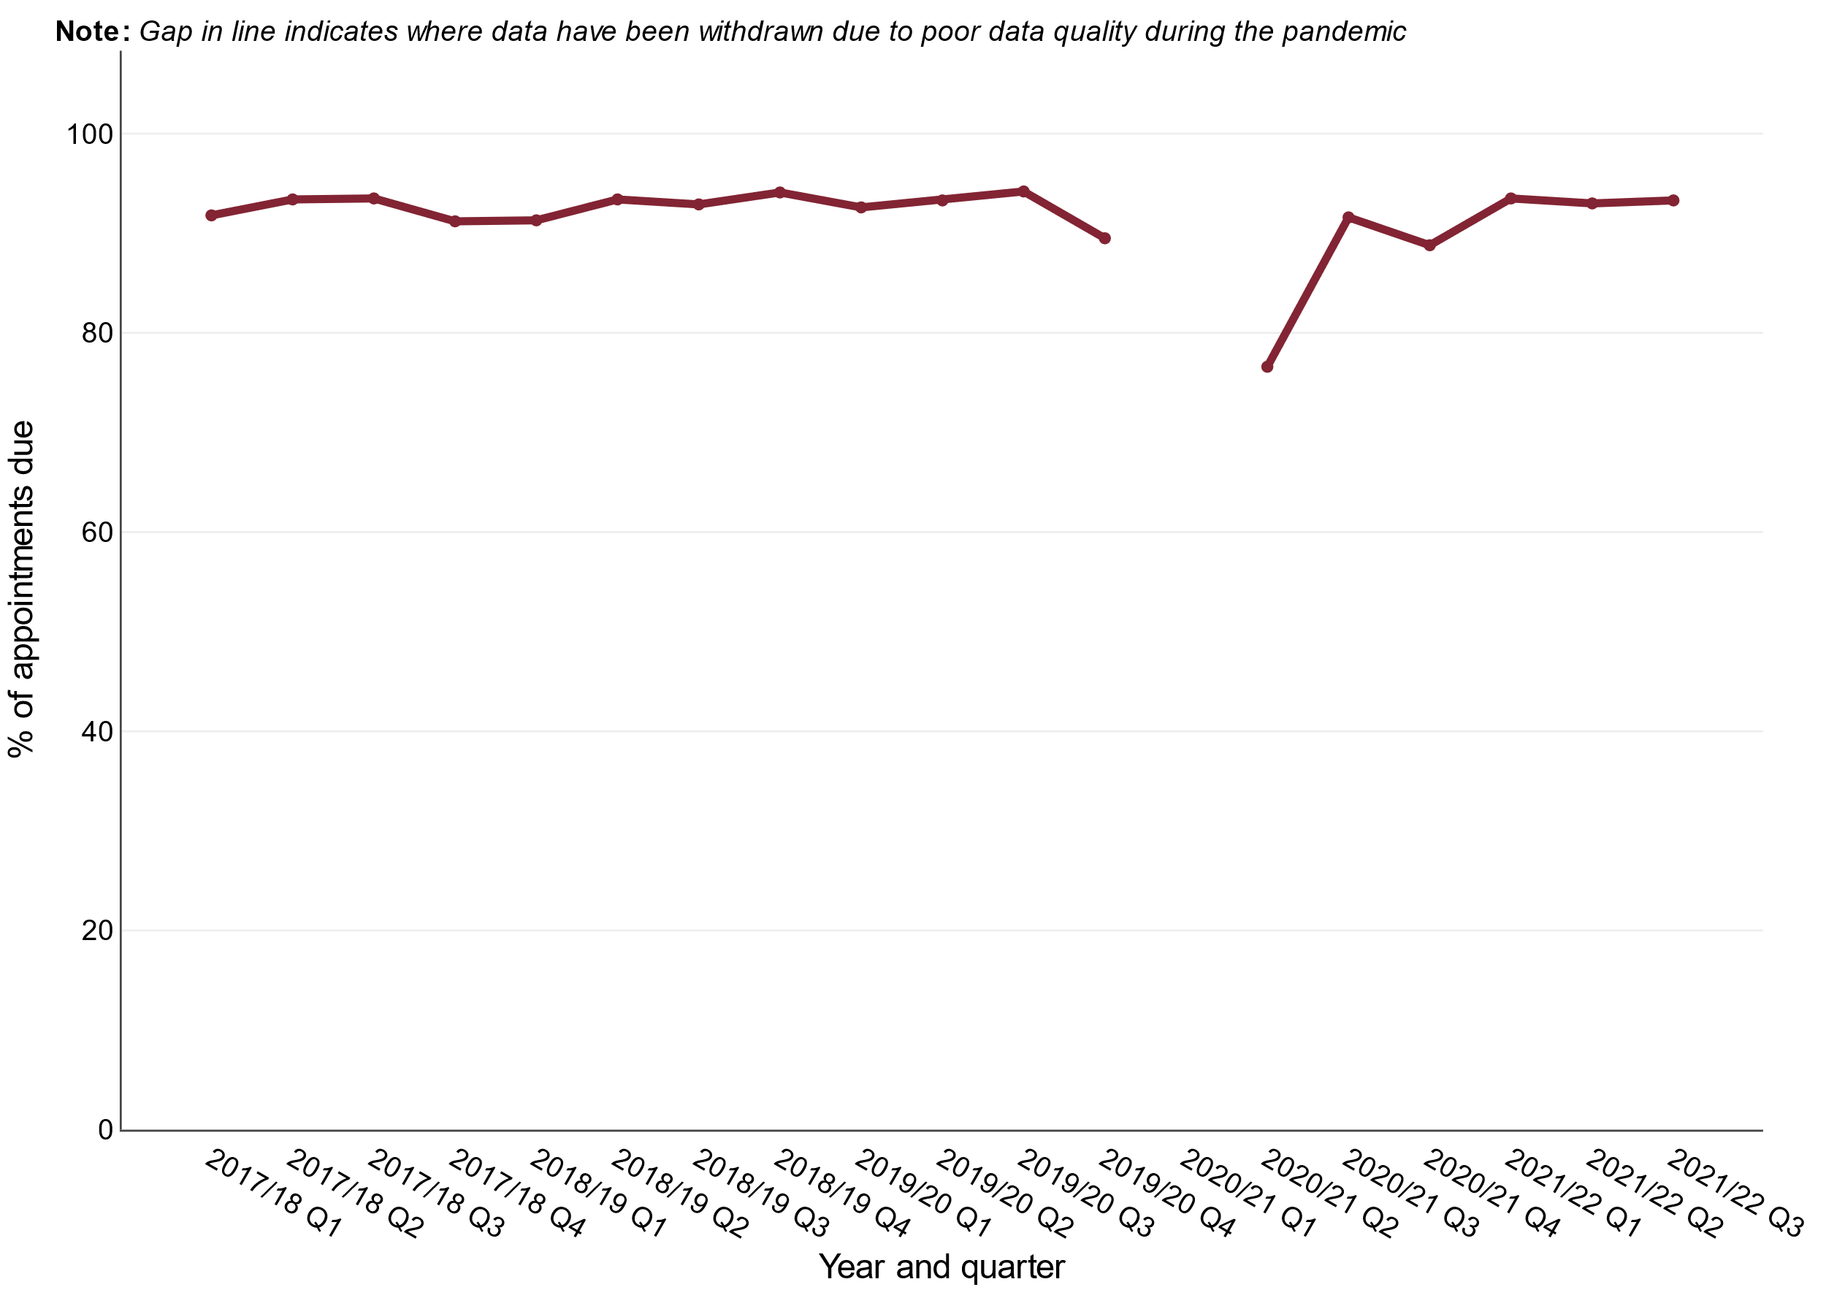
Figure 6: Proportion of quarterly abdominal aortic aneurysm surveillance appointments due where there is a conclusive scan within 4 weeks either side of the due date, April 2017 to December 2021, England

Source: Screening key performance indicators, NHS England and NHS Improvement

Breast cancer screening

Figure 7 shows the proportion of eligible women aged 50 to 71 who had a technically adequate breast screen within 6 months of their date of first offered appointment (uptake). Between April 2017 and December 2019 uptake was approximately 67% and it had declined from 77% in 2011.

For quarters 1 and 2 in 2021 to 2022 uptake was approximately 56%. However, it decreased slightly to 54.5% in quarter 3 2021 to 2022.

Figure 7: Proportion of eligible women who have a technically adequate screen less than or equal to 6 months of date of first offered appointment, April 2017 to December 2021, England
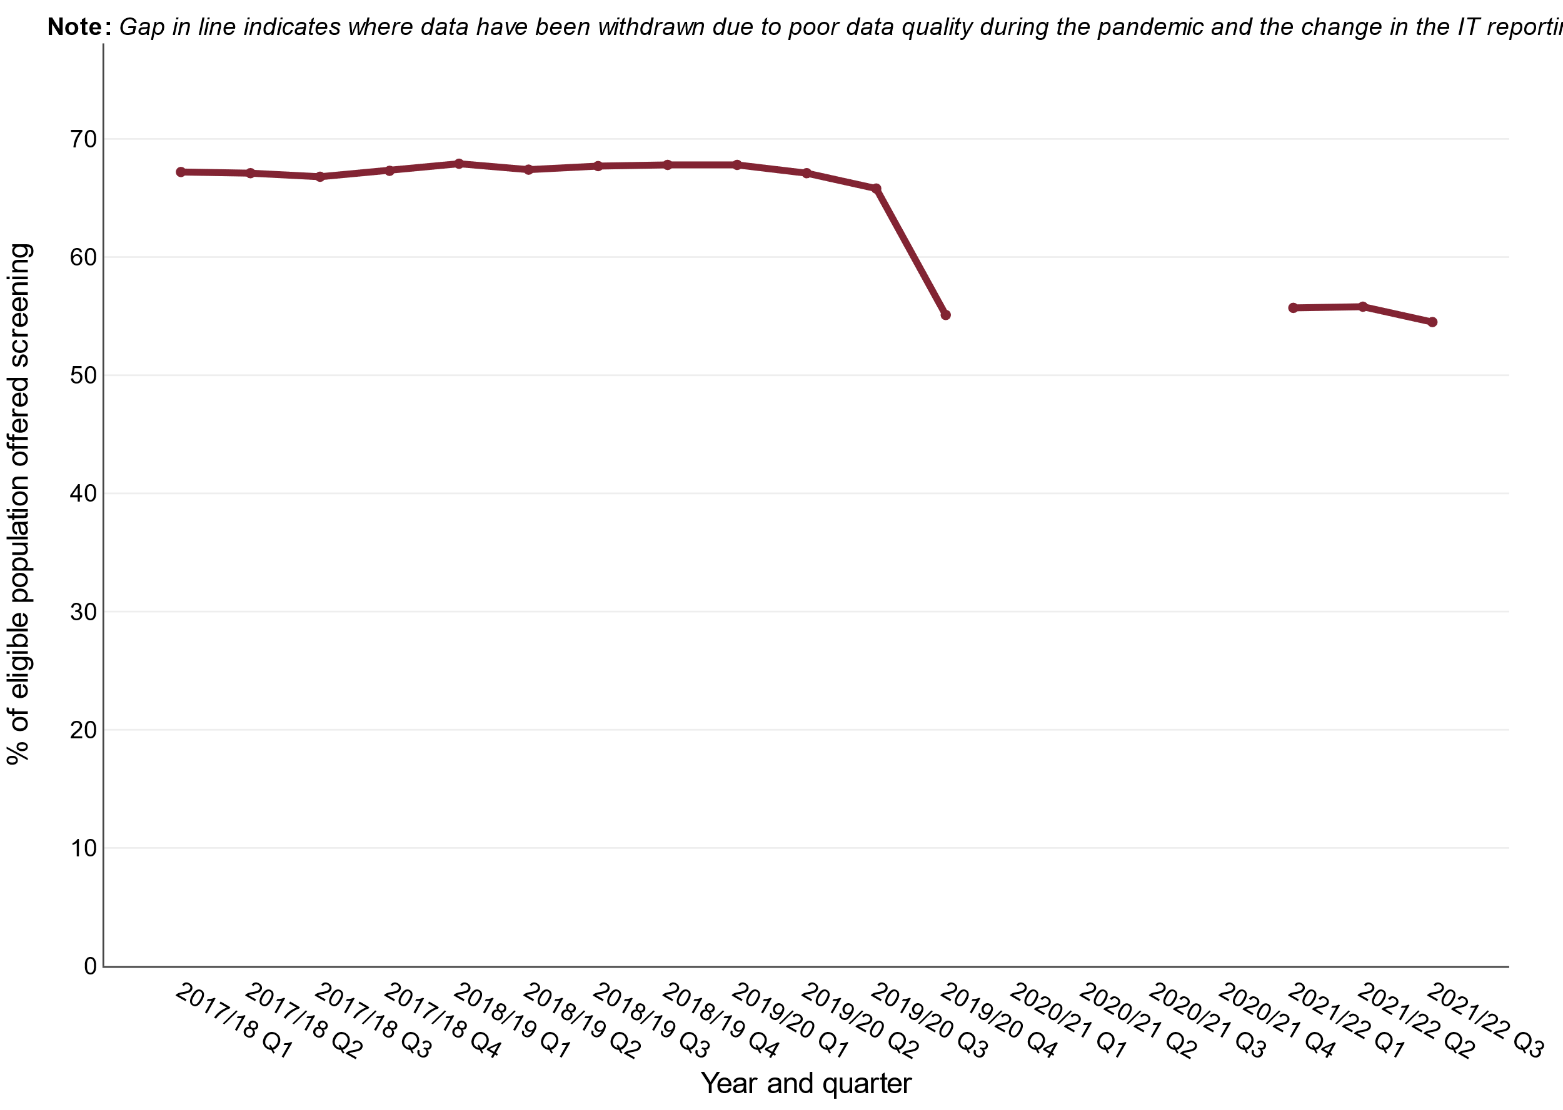
Source: Screening key performance indicators, NHS England and NHS Improvement

Figure 8 shows the proportion of eligible women who have had a previous invitation for breast screening, that have a subsequent invitation within 36 months (this proportion is known as the screening round length). It is important for women to receive a timely invitation in order to increase the chances of finding cancers early but reduce the harms of over diagnosis and radiation exposure. Breast screening round length declined from 90.6% in quarter 1 2017 to 2018 to 81.8% in quarter 4 2019 to 2020.

In March 2020, all 78 NHS Breast Screening units made the decision to pause screening for approximately 3 months between March 2020 and June 2020. Due to the number of women requiring screening that built up during the pause in screening many invitations were delayed. The screening round length of 21% in quarter 1 2021 to 2022 reflects the difficulties providers had with recovering from the effects of the pandemic on service provision. Screening round length has improved each quarter in 2021 to 2022, reaching 30.7% in quarter 3. Screening round length is expected to improve further as screening providers reduce the number of delayed invitations.

Figure 8: Proportion of eligible women whose date of first offered appointment is less than or equal to 36 months of their previous episode*, April 2017 to December 2021, England
* The previous episode refers to date of screening for women who attended or date of first offered appointment for women who did not attend
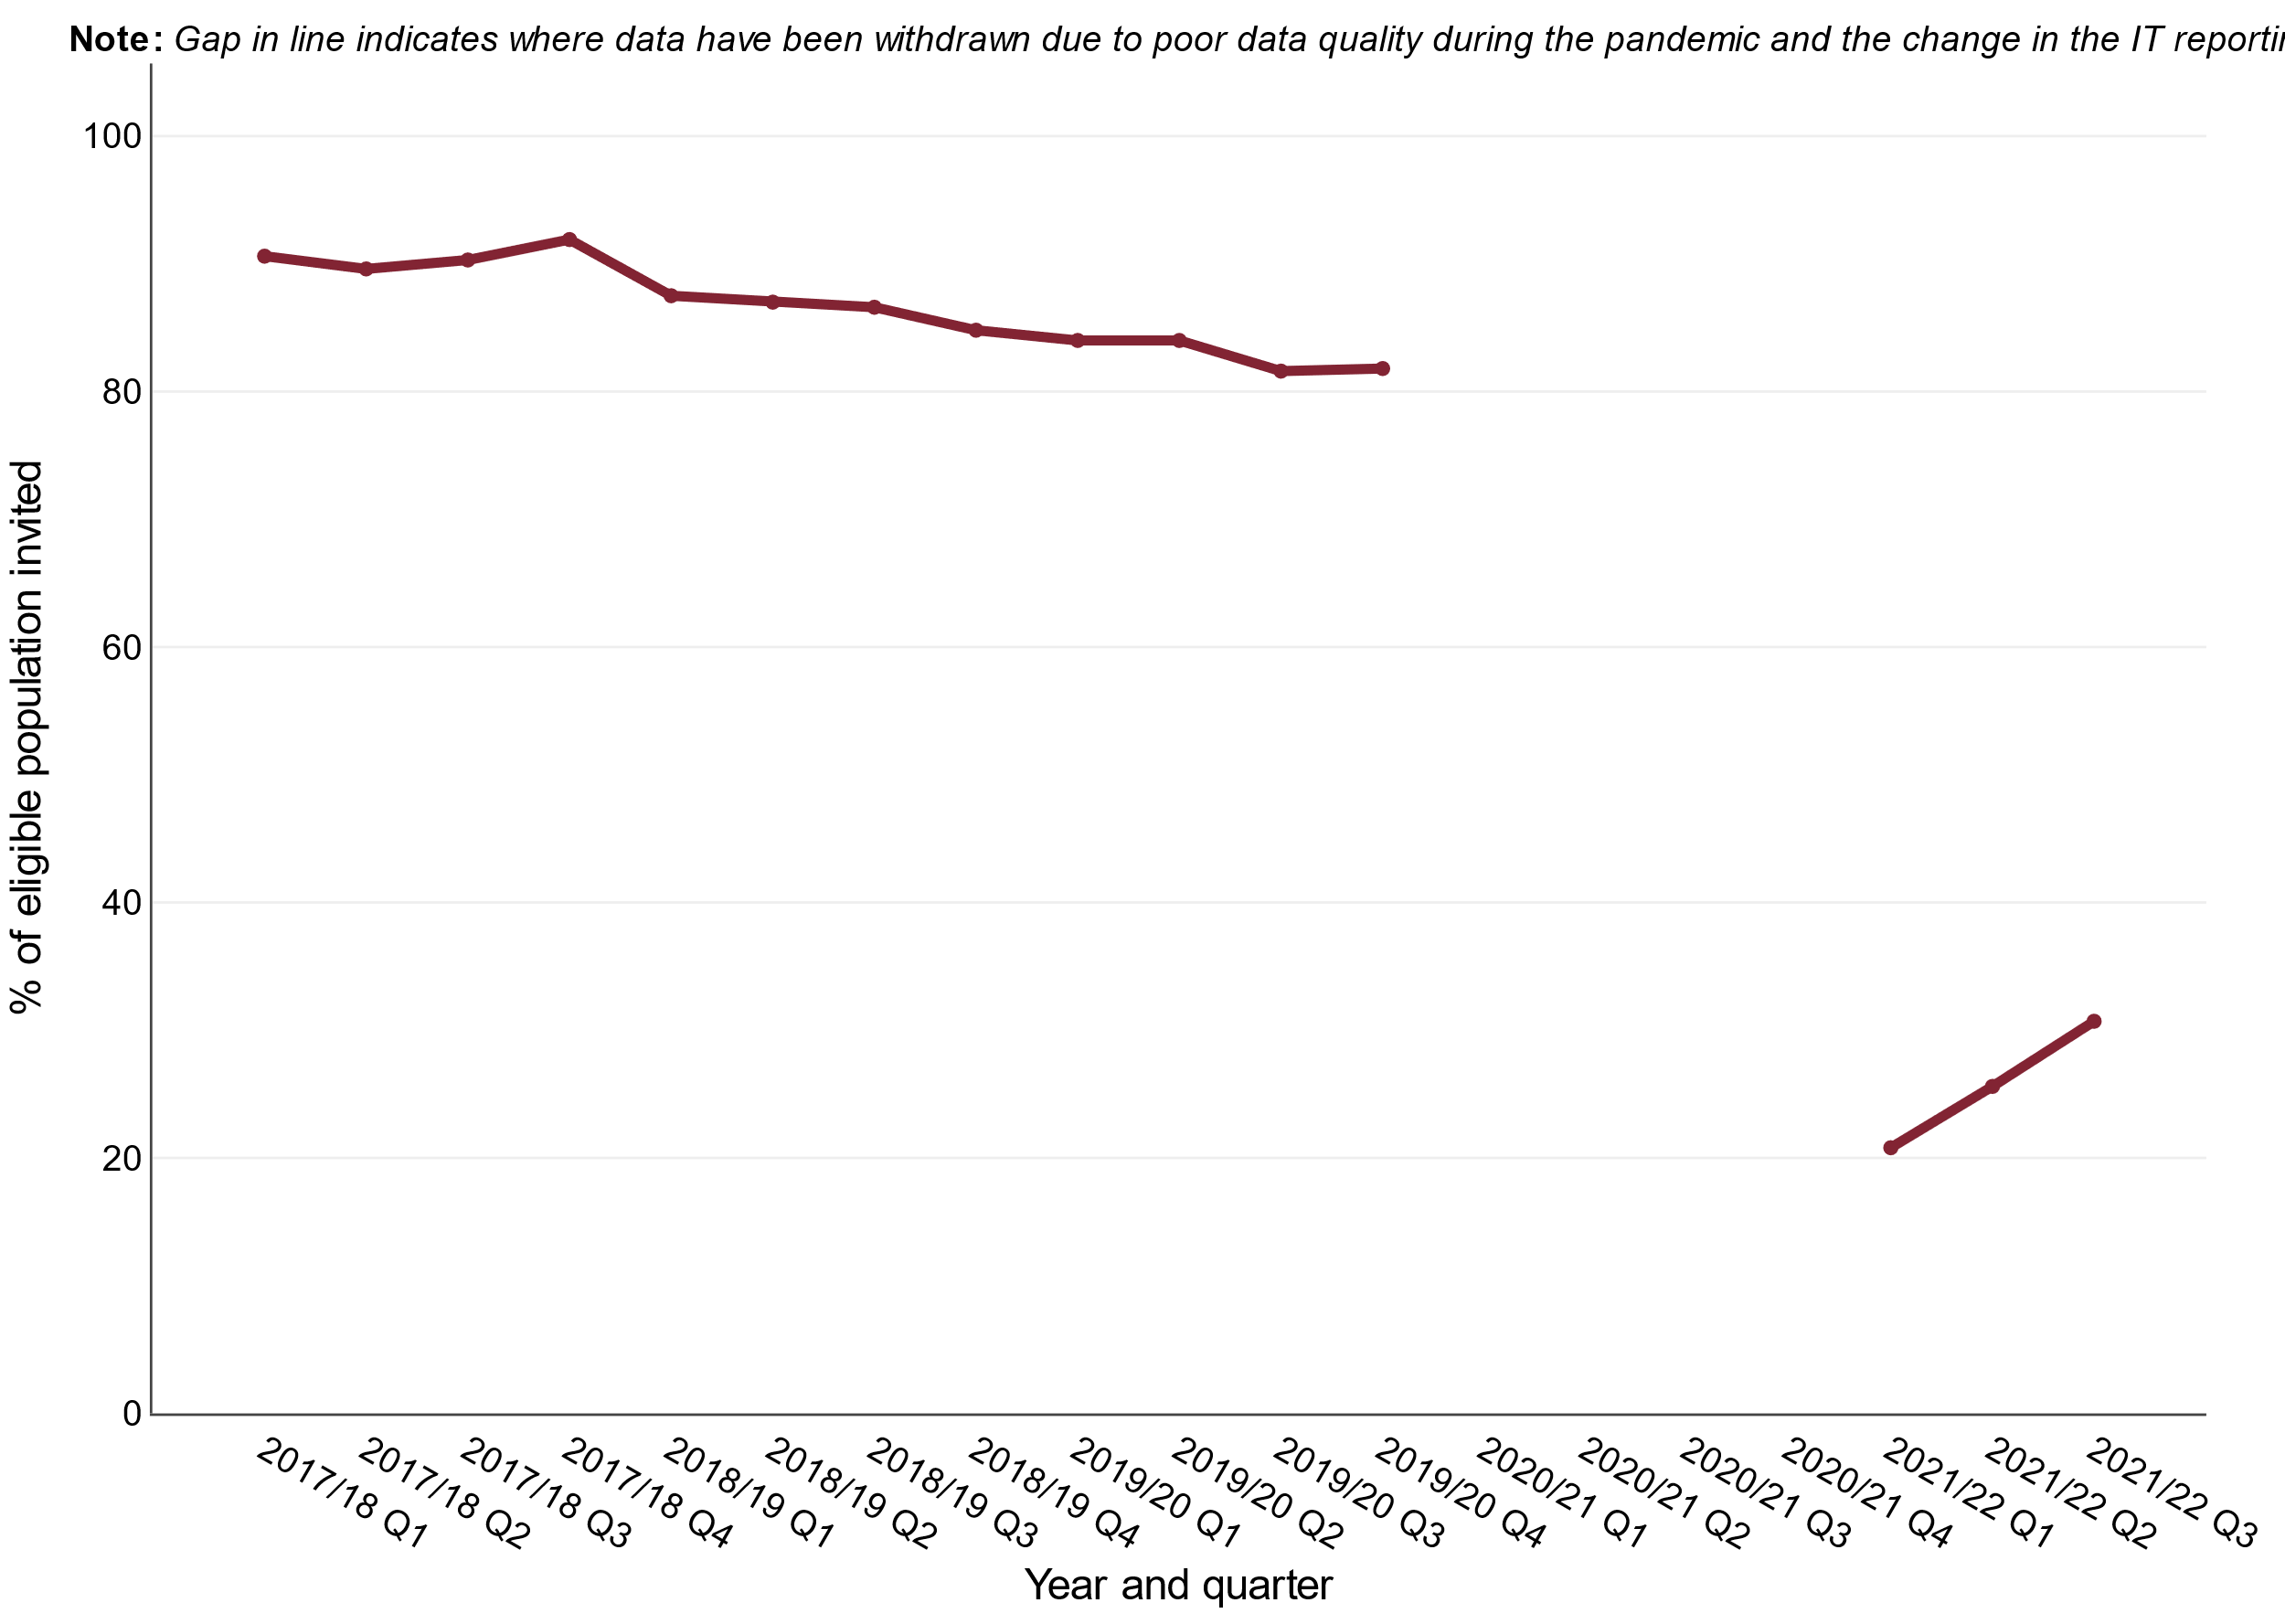
Source: Screening key performance indicators, NHS England and NHS Improvement

